2. Asian Americans In Queens, NYC

Where do Asians live in New York City?
In 2010, nearly half (49.3%) of Asians lived in Queens, followed by Brooklyn (25.3%), Manhattan (17.3%), Bronx (4.8%), and Staten Island (3.4%).² The New York City Department of City Planning's map above demonstrates neighborhood concentrations of Asian populations.⁴

How many Asians live in New York City?
Out of 8,008,278 New York City residents counted during the 2010 Census, 1,038,388 (12.7%) identified as Asian alone. Including Asians in combination with other races, the number rises to 1,134,919 (13.9%).^{1,2} More Asians live in New York City than in any other city in the United States.³

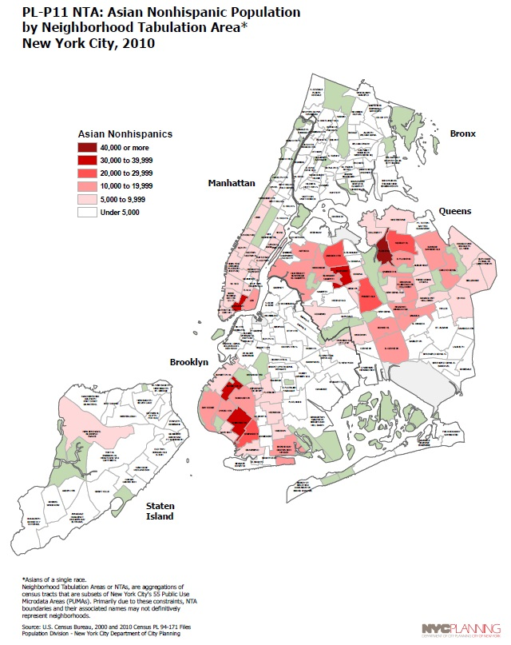
Reproduced from NYC Department of Planning map, "PL-P11 NTA: Asian Nonhispanic Population by Neighborhood Tabulation Area, New York City, 2010⁴

What populations of Asians can you find in Queens?
Queens is the most diverse county in the entire United States, and its rich, multicultural heritage is a result of the people from all over the world who come here to build communities. Asians in Queens include sizable multiracial and/or diasporic Asians, such as Asian Caribbeans or Latin Americans.
The largest Asian subgroups in Queens are Chinese and Taiwanese, Asian Indian, Korean, Filipino, and Bangladeshi. However, there are also significant numbers of smaller populations of Asians who should not be overlooked, such as communities hailing from Nepal, Pakistan, and Southeast Asian countries. There is also a large number of multiracial Asians as well. ²

Asian subgroup | New York City | Queens²
Total Asian Only | 1,038,388 | 511,787
Asian Indian | 192,209 | 117,550
Bangladeshi | 53,174 | 33,152
Bhutanese | 345 | 240
Burmese | 3,614 | 2,132
Cambodian | 2,166 | 230
Chinese and Taiwanese | 486,463 | 199,469
Filipino | 67,292 | 38,163
Hmong | 59 | 24
Indonesian | 3,785 | 2,860
Japanese | 24,277 | 6,375
Korean | 96,741 | 64,107
Laotian | 440 | 137
Malaysian | 2,100 | 1,029
Nepalese | 5,681 | 4,930
Pakistani | 41,887 | 16,215
Sri Lankan | 3,696 | 1,293
Thai | 6,056 | 3,677
Vietnamese | 13,387 | 3,566
Other Asian and Persons of Two or More Asian Groups | 35,016 | 16,638
Asian in Combination with Another Race | 96,531 | 41,080

How many Asians live in Queens, New York?
511,787 (22.9%) Asians were counted as living in Queens, New York in 2010. Including those reporting additional races, 552,867 (24.8%) were reported.²

References and further reading
¹ New York City Department of City Planning. (2011, March). Table PL-P1 NYC: Total Population New York City and Boroughs, 2000 and 2010. Retrieved May 25, 2014 from http://www.nyc.gov/html/dcp/pdf/census/census2010/t_pl_p1_nyc.pdf
² New York City Department of City Planning. (2012, June). Table SF1-P9 NYC: Total Asian Population by Selected Subgroups New York City and Boroughs, 2010. Retrieved May 25,2014 from http://www.nyc.gov/html/dcp/pdf/census/census2010/t_sf1_p9_nyc.pdf
³U.S. Census Bureau. (2012). The Asian Population: 2010 . Retrieved May 25, 2014 from http://www.census.gov/prod/cen2010/briefs/c2010br-11.pdf.
⁴ New York City Department of City Planning. PL-P11 NYA: Asian Nonhispanic Population by Neighborhood Tabulation Area* New York City, 2010 . Retrieved May 25, 2014 from http://www.nyc.gov/html/dcp/pdf/census/census2010/m_pl_p11_nta.pdf
Fessenden, F. & Bloch, M. (2011) . Asians in New York City. The New York Times. Retrieved from http://www.nytimes.com/interactive/2011/06/23/nyregion/new-york-asians.html?_r=0

