4. Asian Migrations to the Americas
Today, Asian Americans are one of the most dynamic, diverse, and fastest-growing populations in New York City and the United States. These communities have been shaped by forces such as U.S. immigration policy and labor migrations. In the nineteenth century, large numbers migrated from different parts of Asia and formed sizeable diasporic communities all over the world including in North, Central, and South America, and the Caribbean. The relationship between the United States and various Asian countries influenced immigration trends, and the ability of immigrants to form permanent communities and maintain ties to their homelands.¹

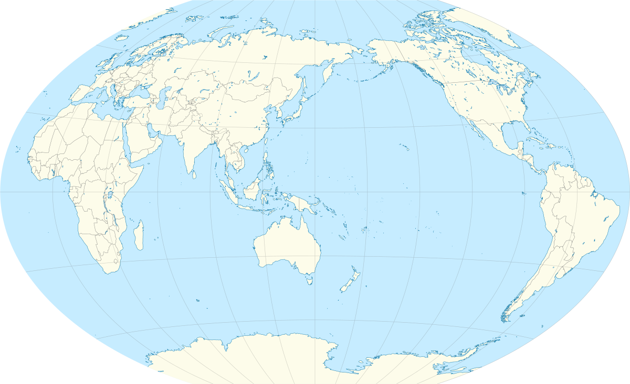
KOREA
JAPAN
PHILIPPINES
INDIA
CHINA

Why did Asians leave their home countries?
Between 1840-1900, over 2 million Chinese migrated to other countries in the wake of heavy taxation, poverty, and economic upheaval after the British Opium Wars and Taiping Rebellion. Many Fujianese migrants were offered contract labor as "coolies" and were virtually enslaved and sent to European colonies in the Caribbean and Latin America. Word of the California Gold Rush reached port cities in Canton, leading to a wave of Chinese migrants moving to the U.S. West Coast seeking their fortunes. These immigrants formed almost exclusively male "bachelor societies", and worked in mining and railroad construction, but also opened restaurant and laundry businesses.¹

CHINA

After a period of commercial colonialism, the British government established full colonial rule in India in 1858. This lead to an imposition of British culture on Indians, increased production of export crops, suffocation of local commerce, and widespread famine killing millions. Starting in 1899, small numbers of mostly Punjabi men left their families for Canada and British colonies such as British Guiana, British West Indies, and Uganda, in hopes of earning enough money to pay off debts. In California, they traveled in small groups as seasonal farm workers.¹
INDIA

The Meiji Restoration in Japan (1852-1921) was characterized by a period of "opening up" and rapid industrialization resulting in high taxes, displacement of farmers, and food shortages. Landless Japanese farmers with aspirations of purchasing land in Japan set their sights on Hawaii's cane fields as a source of income. As "sojourners", they worked on Hawaii's sugar and pineapple plantations for three to five year contracts. On the U.S. mainland West Coast, they worked in agriculture and established small businesses.¹
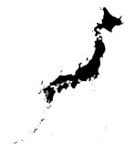
JAPAN

Why did Asians leave their home countries?

Korea had been treated as a pawn in Asian conflicts such as the Sino-Japanese War (1894), and later the Russo-Japanese war (1904). Japan officially annexed Korea in 1910 and imposed totalitarian rule for the next 35 years. Koreans faced extreme poverty, as millions lost their land and faced economic upheaval, war, and famine. When Christian missionaries and the Hawaiian Sugar Planters Association began recruiting in Korea in 1900 and painted idealistic pictures of Hawaii, thousands of families chose to migrate. From Hawaii, some Korean families made the additional trip to California.¹
KOREA

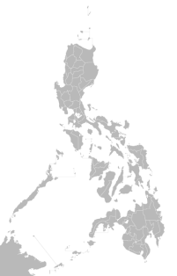
Following an incident with Spanish-controlled Cuba, the United States captured Manila, Philippines in 1898 to use in negotiations with Spain. In 1899, the start of the U.S.-Philippine War, Filipinos balked at U.S. occupation and sought to recapture control of their country. However, the U.S. annexed the Philippines in 1903 with a policy of "benevolent assimilation." Following the annexation, Filipinos began emigrating to the United States as "American nationals." They were also actively recruited to Hawaii as a source of cheap labor, especially after other Asian groups were barred from emigration. Filipinos on the mainland most often worked as seasonal farm workers and urban service industries.¹

PHILIPPINES
Following an incident with Spanish-controlled Cuba, the United States captured Manila, Philippines in 1898 to use in negotiations with Spain. In 1899, the start of the U.S.-Philippine War, Filipinos balked at U.S. occupation and sought to recapture control of their country. However, the U.S. annexed the Philippines in 1903 with a policy of "benevolent assimilation." Following the annexation, Filipinos began emigrating to the United States as "American nationals." They were also actively recruited to Hawaii as a source of cheap labor, especially after other Asian groups were barred from emigration. Filipinos on the mainland most often worked as seasonal farm workers and urban service industries.

PHILIPPINES

References
¹Avakian, Monique. (2002). Atlas of Asian-American History. Hong Kong: Media Projects Inc.

