5. Asian American History:

Exclusion, Discrimination, and Advocacy

Asian Exclusion

Immigration Policy
The Nationality Act of 1870 excluded people of color from citizenship of the United States.
Chinese Exclusion Act of 1882: a ten year ban was placed on the immigration of Chinese laborers to the United States. This act is the only act in U.S. history that explicitly excludes a specific nationality of people from immigration. It was repeatedly renewed until 1943.
The Gentlemen's Agreement of 1908: Japan promised to restrict immigration of its citizens to only former residents and families of residents, and not laborers. The Immigration Act of 1907 banned migration of Japanese from Hawaii, Mexico, and Canada to the U.S. mainland.
1913 California Alien Land Law: forbade land purchase in California by Asian immigrants.
1917 "Asiatic Barred Zone" banned immigrants from India, Afghanistan, Southeast Asia, and the East Indies from coming to the United States.
Cable Act of 1922: American women who married immigrants who were ineligible for citizenship would have their own citizenship revoked.

The number of laborers emigrating to the U.S. from Asia rapidly grew during the nineteenth century. These Asian immigrant communities faced harsh racism in the form of labor exploitation, discrimination, violence, and exclusionary policies, as anti-Asian sentiment escalated among white Americans. Although they suffered, these early Asian American communities also stood up for themselves and organized.
Labor exploitation & Asian American labor movements: From the start, labor practices for Asian immigrants were exploitive; they were often counted upon to do the dangerous and grueling work shunned by their white counterparts for very little pay (e.g. working on sugar cane plantations, or blasting tunnels for building the transcontinental railroad). From the start, Asian immigrants formed community organizations designed to provide assistance and sometimes justice for themselves and to help recent immigrants in settling in. There were also early sporadic attempts to resist working conditions. In Hawaii, Japanese plantation workers successfully went on strike to demand higher wages in 1906, and developed consciousness among the workers to support strikers within their communities. Unions originally organized around ethnicity, but in 1920, Japanese and Filipino joined forces given their common concerns. In the 1930s, thousands of Filipino farm workers on the mainland organized to form the Filipino Labor Union.
Anti-Asian sentiment: With America's poor economy in the late 1800s, many white workers looked to Asians as scapegoats and a threat to job security. They were seen as the "Yellow Peril": foreign hoards coming to take over the U.S. Hate groups, such as the Asiatic Exclusion League, and political parties such as the Workingman's party and "Know-Nothing" party, further inflamed racist sentiments and policies.
1917 "Asiatic Barred Zone" banned immigrants from India, Afghanistan, Southeast Asia, and the East Indies from coming to the United States.
Cable Act of 1922: American women who married immigrants who were ineligible for citizenship would have their own citizenship revoked.
1923 United States v. Bhagat Singh Thind: Although Indians are "Caucasian" and would technically not be barred from citizenship based on identity, this Supreme Court case ruled that "Caucasian" actually referred to "white" only. As a result, Sikh Americans suddenly lost citizenship and therefore their right to the land that they owned. Over 3,000 Indians returned to Asia in the 1920s, but others found loopholes to landownership, like putting deeds under the names of their white friends, American-born children, or Mexican-American wives.
Immigration Act of 1924: restricted the number of new immigrants annually from all nationalities to 2% of their numbers in 1890.
Tydings-McDuffie Independence Act of 1934: promised independence to the Philippines in 10 years time and shifted its political status to "commonwealth", which also changed the citizenship status of Filipino Americans from citizens to "legal aliens".

Mob Violence: Asians of essentially all major groups experienced segregation, mob violence, and efforts to drive them out. During the Gold Rush of the mid-1800s, Chinese miners were victims of anti-Chinese violence and murder that went unpunished, especially given the 1854 California Supreme Court ruling that only whites could give testimony in court. In the early 1920s, violent mobs in many towns in California and Oregon drove Japanese immigrants out of town while law enforcement turned a blind eye. Filipinos were also victims of violence during the Great Depression; whites tried to get farm owners to fire Filipino workers, violently drove them out of their homes, and attacked Filipino men based on their perceived threat to white women.
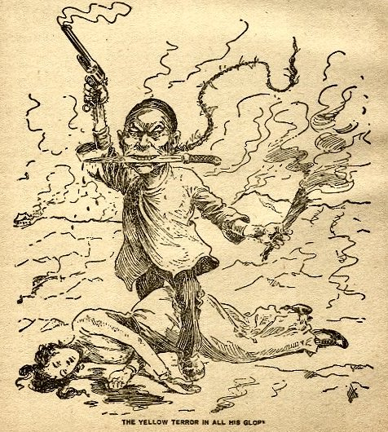
1899 editorial cartoon "The Yellow Terror in all his glory"¹
Exclusionary Immigration Policy: Asian immigrants faced some of the most exclusionary policies in U.S. history. Anti-Asian sentiment solidified in laws that forbade and severely restricted immigration from countries in Asia, the ability of Asians to own land, and the right of Asians to become naturalized citizens (see "Immigration Policy" box). Between 1910-1940, thousands of Asians entered the country through Angel Island, an immigrant holding facility in San Francisco Bay, and thousands more were turned away for failing to pass interrogations and paperwork checks. Over all, numbers of Asians entering the U.S. remained relatively low until the mid-1900s.

World War II
Tydings-McDuffie Independence Act of 1934: promised independence to the Philippines in 10 years time and shifted its political status to "commonwealth", which also changed the citizenship status of Filipino Americans from citizens to "legal aliens".
War Brides Act of 1945: Chinese, Filipino, and Korean wives and children of men in the U.S. military were allowed immigration to the U.S. This act dramatically increased the number of Asian women in the U.S., and lead to a population boom especially in Filipino and Korean American populations.
1952 McCarran-Walter Act: previously ineligible foreign-born Asian immigrants were granted naturalized citizenship. The attorney general was given the ability to deport immigrants with suspected Communist ties. Each Asian country was given a quota of 105 immigrants annually, while European countries had no quota.

During World War II, imperialist Japan invaded other countries in Asia and eventually attacked Pearl Harbor in 1941, which initiated America's involvement in the war. This turn of events had varying effects on Asian American groups.
Japanese Americans were overwhelmingly loyal to the U.S. Many Japanese Americans in Hawaii had defended Pearl Harbor during the invasion. Japanese Americans who initially tried to enlist in the army were rejected on racial grounds. The 442nd Regimental Combat Team, a segregated regiment of American-born Japanese soldiers, became the most decorated in the entire war and distinguished itself for bravery and skill on the front lines in Italy and Germany. However, anti-Japanese hysteria increased as fears of spying escalated. In 1942, President Franklin Roosevelt signed Executive Order 9066, which became the basis of forcing over 110,000 Japanese Americans from their homes and relocating them in ten military-style Internment Camps. Although the Order violated their civil rights and almost 70,000 of those interned held U.S. citizenship as second generation Japanese Americans, they largely obeyed the order since they were concerned that resistance would be perceived as disloyalty.
Chinese, Korean, and Filipino Americans had their homelands attacked by Japan and welcomed America's firepower against a common enemy. White prejudice against these groups declined, because they contributed enthusiastically to war efforts and their home countries were now political allies with the U.S. However, thousands also felt compelled to wear buttons or badges proclaiming "I Am Chinese" or "I Am Korean" in order to avoid anti-Japanese harassment.
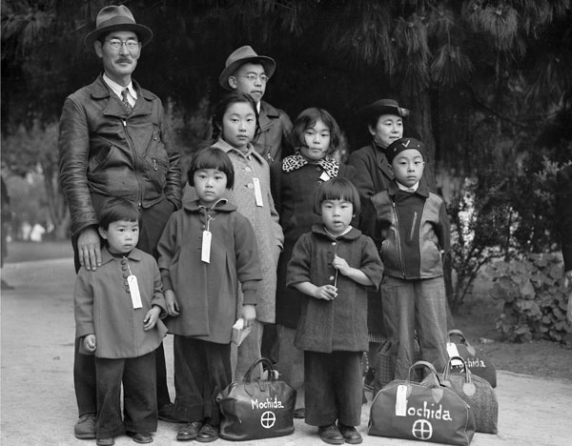
"Members of the Mochida family awaiting evacuation bus. Identification tags were used to aid in keeping a family unit intact during all phases of evacuation. Mochida operated a nursery and five greenhouses on a two-acre site in Eden Township."²

Civil Rights Era
The expansion of employment opportunities for women and minorities during World War II, postwar economic growth in the U.S., and population growth over all lead to an era of prosperity, opportunity, and empowerment for many communities including Asian Americans.
Redress Movement: In 1945 Japanese Americans were released from forced internment camps and returned home to find that most had lost all their property and had to start over again and rebuild their communities. Japanese Americans organized and drafted proposals through the Japanese American Citizens League during the 1970s to strategize how to seek reparations from Congress. In 1980, Congress established the Commission on Wartime Relocation and Internment of Civilians. This Commission found that internment of Japanese Americans was an injustice and merited monetary compensation. In 1988, the U.S. government formally apologized to all those interned, established the Office of Redress Administration, and awarded $20,000 to each incarcerated person.
Asian American Activism: Empowered by civil rights victories of African Americans and messages of ethnic pride and minority rights from the Black Power movement, Asian Americans protested and organized in solidarity with other minorities on issues of civil rights and resisting the status quo. The "Yellow Power" movement emerged when Asian American students at San Francisco State College went on strike with African American students in 1969 to establish the country's first school of ethnic studies. Asian American activists were also active participants in the Vietnam War protests, the redress movement, and community service organizing in urban Chinatowns and Little Tokyos.
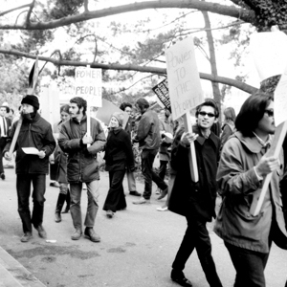
1968 San Francisco State College student strike³
Political Representation: Hawaii's democrats successfully lobbied for statehood in 1959. The fiftieth state elected some of the U.S.'s first Asian American representatives, including Daniel Inouye, Hiram Fong, and Patsy Mink.
Conflicts in Southeast Asia: During the Cold War, Southeast Asia suffered violent instability due to the U.S.-aided Vietnam War (1955-1975), and Pol Pot's regime in Cambodia. As a result, hundreds of thousands of Vietnamese, Laotian, Cambodian, and Hmong refugees fled to the U.S. Given that refugees tended to be poorer and undereducated and had suffered trauma, many of these immigrant communities continued to experience disadvantage in the U.S.

Hart-Cellar Act of 1965
The Hart-Cellar Act of 1965 was a landmark piece of legislation that ended the country quota system of immigration, and granted entry to 170,000 immigrants from the Eastern Hemisphere and 120,000 to the Western Hemisphere annually (with a maximum of 20,000 immigrants per country). Furthermore, immigrants who established citizenship were then allowed to bring over their immediate families as permanent residents. The Act granted immigration based on prioritized preferences: 1. family reunification (i.e. children, siblings, and spouses of U.S. citizens and permanent residents), 2. "exceptional ability" (i.e. educated and skilled professionals, scientists, artists), 3. occupations in short supply in the U.S., and 4. refugee status.
The Act caused unprecedented growth in all Asian American populations, especially for Korean and Indian Americans. While the number of Asian immigrants entering the U.S. was only 16,062 in 1965, this number grew to 116,521 by 1975. The Act also impacted the socioeconomic demographic of Asian American communities. For example, while most South Asian immigrants from the early 1900s were rural Sikh laborers, most immigrating after this Act tended to be highly educated urban professionals who were already proficient in English. This shift in trends was also the case for Chinese, Korean, and FIlipino Americans as well.⁴

References
¹Ono, K.A., & Pham, V. (2008). Asian Americans and the media. Wiley, p 30.
² Lange, Dorothea. (1942). "Members of the Mochida family awaiting evacuation bus. Identification tags were used to aid in keeping a family unit intact during all phases of evacuation. Mochida operated a nursery and five greenhouses on a two-acre site in Eden Township." Hayward, California. National Archives and Records Administration, Records of the War Relocation Authority. May 8, 1942
³Springer, Denize. (2008). Campus commemorates 1968 student-led strike. Retrieved from http://www.sfsu.edu/news/2008/fall/8.htm June 15, 2014.
⁴Avakian, Monique. (2002). Atlas of Asian-American History. Hong Kong: Media Projects Inc.

