8. Asian Americans and Health

sparse. According to a study, between 1986-2000, only 0.2% of federal grants involved Asian American and Pacific Islander (API) health. Not surprisingly, a review of health articles published between 1966-2000 revealed that only 0.01% involved API health, and most of it was for aggregated Asians which is of limited utility for improving the health of specific subgroups.

Accurate health data is key in informing public policy as well as public health interventions and agendas for Asian Americans. Therefore, API advocacy groups have pushed for oversampling of Asians in national surveys, disaggregation of Asian sub-groups in reporting, and increased funding and research, in order to address the above health data problems.1

## What are the leading causes of death for Asian Americans?

According to the Center for Disease Control and Prevention, the 10 leading causes of death for Asian Americans in 2010 were:

|  |  |
| --- | --- |
| **1. Cancer**  **2. Heart Disease** | **6. Influenza and Pneumonia** |
| **3. Stroke**  **4. Unintentional** | **7. Chronic Lower Respiratory Disease** |
| **Injury** | **8. Kidney disease** |
| **5. Diabetes** | **9. Alzheimer's Disease** |
|  | **10. Suicide**2 |

## Why is race important in health?

Public health research has demonstrated that health outcomes differ by race, and minorities often suffer disparities and poorer outcomes. Each group has their own sociocultural context for health behaviors, lives in different environments with different barriers to health, and faces different types of discrimination. All these factors have the potential to impact health and well-being.

## Why is it hard to find accurate health information on Asian Americans?

**Small sample size**: Populations of Asian Americans are relatively small in the United States, and therefore the number of Asians sampled in national health surveys may not always be enough to have their own category in results, or to reach statistically valid conclusions.

**Aggregation of data**: The label "Asian" encompasses an enormous diversity of people hailing from the largest continent, so aggregated data collected on Asians may lump together groups with very different backgrounds and health trends. This is especially problematic for smaller subgroups of Asians (e.g. Hmong or Nepalese) whose health trends are obscured by larger groups (e.g. Chinese, or Indian).

**Lack of research and funding**: The volume of health research conducted for Asian American communities has been disproportionately

**Lack of familiarity with U.S. Systems**: Asian immigrants, especially recent or LEP immigrants, may have limited understanding of the ponderous U.S. medical system and how to navigate it. They may not be aware of services available to them, or how to apply for benefits. Although everyone has the right to emergency medical care regardless of immigration status or ability to pay, immigrants sometimes forgo care with tragic consequences because they do not know this or they fear deportation.

**Cultural competency**: Asian immigrants may not have familiarity with the U.S. medical system and may not hold western biomedical worldviews of health and wellbeing. They may also use complementary and alternative therapies, such as Chinese herbal medicines, acupuncture, or coining. U.S. medical professionals are not always informed of other cultural norms and ways of healing, and are not equipped to care for patients in a culturally sensitive way. Patients may have negative encounters with the healthcare system and be more reluctant to seek care. This highlights the need for bicultural medical professionals and training in cultural competency.

**Social stigma**: Asian Americans are the least likely group to use mental health services (8.6%, versus 17.9% of non-Asians). This is even the case for individuals with probable diagnosable psychiatric conditions. Social stigma and shame associated with mental health and other topics (e.g. sex or developmental delay) inhibit many from seeking medical care.1

## What issues prevent Asian Americans from accessing health care?

**Language barriers**: The majority of Asian Americans speak a language other than English at home, and have high rates of limited English-proficiency (LEP). (See sheet "Asian American Communities in Queens: a demographic snapshot" for additional information). Without a trained medical interpreter or bilingual staff, patients with LEP are unable to accurately describe symptoms, ask questions, understand crucial medical instructions, and understand their medical condition to make informed decisions about their care. The right to a professional medical interpreter at no cost is supported by federal law and various executive orders prohibiting discrimination and mandating language access. However, these measures are not always implemented, and the consequences can be fatal. 1

**Lack of insurance**: In 2008, there were 2.3 million Asian Americans who did not have insurance in the U.S., with highest rates among Koreans (31%) and Vietnamese (21%). 35% of Asian Americans are self-employed or work in cash-based jobs that usually do not offer health benefits. The Patient Protection and Affordable Care Act has helped to expand coverage, but explicitly exclude some Asian Americans by prohibiting all undocumented immigrants from purchasing insurance in the insurance exchange. Also, while progressive states like New York allow documented immigrants immediate Medicaid coverage, other states have a 5 year waiting period which hurts recent immigrants.

**Percentage of Adults Eighteen Years and Older with Selected Conditions, by Race and Ethnicity, United States, 2004-2006.** Reproduced from Trinh-Shevrin et al. (2009)1

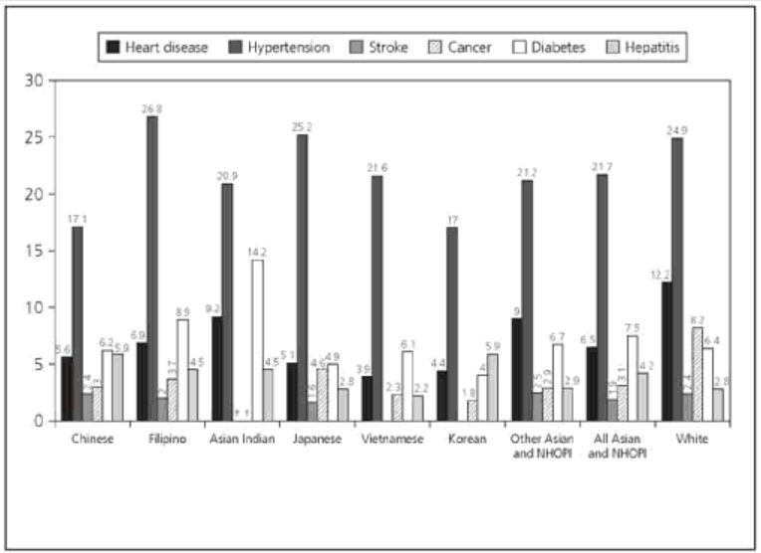

American men have ten times, six times, and five times higher incidence of liver cancer, respectively, compared to their white counterparts. South Asians experience almost four times the risk for hospitalization for cardiovascular disease.1

Meanwhile, Asian Americans are disproportionately affected by some diseases such as **tuberculosis**, which is a respiratory infection. In 2010, they accounted for 28% of all reported tuberculosis cases in the U.S., and 44% of the foreign-born individuals with cases. Asian Americans are also disproportionately affected by **chronic hepatitis b**. In 2011, APIs accounted for 59% of reported cases.5 Those infected are at increased risk for developing cirrhosis and liver cancer.

## How are Asian Americans doing in comparison to other groups?

According to the U.S. Department of Health and Human Service's Healthy People 2010 national report, Asians (sometimes grouped with Pacific Islanders) as an aggregate group had the lowest rates for deaths from motor vehicle accidents, homicide, cancer, diabetes, coronary heart disease, fetal or infant death, chronic obstructive pulmonary disease, drug use, and cirrhosis.4 However, for all health statistics on Asian Americans, it is important to keep in mind that they may vary dramatically across and even within Asian sub-groups. Favorable numbers for aggregate Asians does not indicate that all Asian groups are doing well (see chart below). For example, Vietnamese, Korean, and Chinese

## References

1 Trinh-Shevrin, C., Islam, N.S., Rey, M.J. (2009). Asian American Communities and Health. San Francisco, CA: Jossey-Bass.

2 Centers for Disease Control and Prevention. (2013). "Asian American Populations" http://www.cdc.gov/minorityhealth/populations/REMP/asian.html

3 Abesamis-Mendoza, N., Iwata, M., Lee, Y. Project CHARGE. (2010). Healing the Health Care System: Asian American voices for health care reform. http://www.cacf.org/resources_publications.html

4 U.S. Department of Health and Human Services. (2012). Healthy People 2010 Final Review. http://www.cdc.gov/nchs/data/hpdata2010/hp2010_final_review.pdf

5 Center for Disease Control and Prevention. (2014). "Health Disparities in HIV/AIDS, Viral Hepatitis, STDs, and TB" http://www.cdc.gov/nchhstp/healthdisparities/Asians.html

Vimo, J. (2013). The Language of a Healthier Immigrant New York City: current trends and best practices for providing language assistance services. http://www.thenyic.org/sites/default/files/NYICUHFLanguageAccessReport_Dec2013.pdf

Asian & Pacific Islander American Health Forum. (2013). New York: cancer and Asian Americans, Native Hawaiians & Pacific Islanders. http://www.apiahf.org/sites/default/files/2013%20NY%20State%20Health%20Brief.pdf

Robert Wood Johnson Foundation. (2011). Speaking Together: National Language Services Network. http://www.rwjf.org/content/dam/farm/reports/program_results_reports/2011/rwjf70778

NYU Center for the Study of Asian American Health. http://asian-health.med.nyu.edu/

U.S. National Library of Medicine. (2014). Asian American Health. http://www.nlm.nih.gov/medlineplus/asianamericanhealth.html#cat1