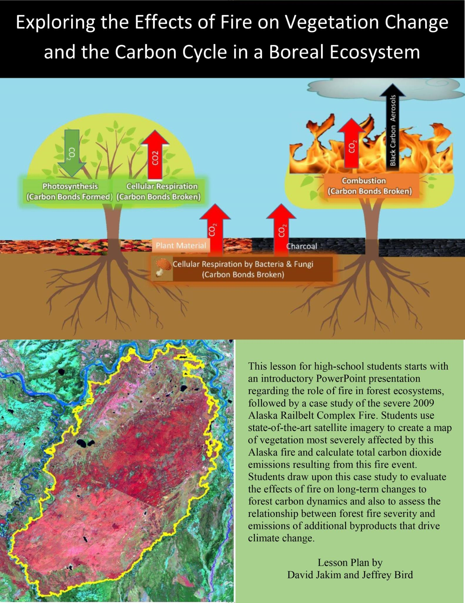

Mapping Forest Fire Burn Severity to Predict
Vegetation Change and Carbon Dioxide Emissions:
A Case Study from Alaska

This lesson plan was developed by David Jakim and Dr. Jeffrey Bird from Queens College with support in part by funding from the National Science Foundation.

Purpose: The purpose of this exercise is for students to map a forest fire, the type of vegetation affected, and the degree to which this vegetation was altered in this fire. Students will calculate the burn area and the amount of carbon dioxide emitted as a result of this fire and use this information to draw conclusions about the change of the forested landscape and the contribution of fires to global warming.

Overview: Students interpret a satellite-generated image of fire burn severity from a 2009 Alaskan wildfire case study and use markers to create a map of high severity burn areas. Using an equal area grid placed upon the map, students measure the area of high severity burns and use this information to calculate carbon dioxide emissions as a result of this fire event.

Student Outcomes: Students learn how to interpret satellite images of fire burn severity, make a map to gain a spatial or landscape perspective of burn severity across a boreal landscape and measure high severity burn areas to help quantify the byproducts of forest fire that effect ecosystem structure and climate change.

Level
Grades 9-12

Time: One double forty-minute class period

Science Concepts Physical
Science
Objects have observable properties that can be measured using tools.
The position of an object can be located by reference to other objects.

Life Science
Earth has many different environments that support different organisms. Ecosystems demonstrate the complimentary nature of structure and function. All organisms must be able to obtain and use resources while living in a constantly changing environment.

Geography
How to use maps.
The physical characteristics of place.
Physical processes shape the environment.
Use maps and appropriate tools and technology to interpret change. The characteristics and distribution of ecosystems.

Scientific Inquiry Abilities
Develop predictions using evidence.
Use appropriate mathematics to analyze data.
Recognize and analyze alternative explanations.
Communicate predictions and explanations.
Use appropriate mathematics to analyze data.

Materials and Tools
Felt-tipped or sharpee color markers.

Powerpoint Presentation

Prints Available in Appendix:
Introduction to Remote Sensing Exercise (Page 5)
Mapping Burn Severity Activity (Page 6 - 7)
2009 Alaska Railbelt Complex Burn Severity Image (Page 8)
2009 Alaska Railbelt Complex Burn Severity Image and Vegetation Map (Page 9)

Preparation
For each student, print color copies of the 2009 Alaska Railbelt Complex Burn Severity Image PDF and the Mapping Burn Severity Activity Sheet.
For each group of students, print and laminate color copies of Introduction to Remote Sensing Exercise and 2009 Alaska Railbelt Complex Vegetation Map for continued use.

Introduction
The sun is the main source of energy for plants, animals and other organisms across the globe. Plants take in energy from the sun and carbon dioxide from the atmosphere to make carbon bonds that store energy; the name of this process is photosynthesis. Plants and animals use these carbon bonds by breaking them down to provide energy needed for life processes, and as a result the carbon atoms are released back into the atmosphere; the name of this process is cellular respiration. In addition, to storing energy, the carbon bonds are also essential building blocks of biomass, that is, the mass of living organisms, including the wood and leaves of trees, decomposers in the soil and animals that eat plants.
A similar reaction to cellular respiration happens in fire; the intense heat breaks down stored energy in the biomass of plant material, releasing carbon dioxide into the atmosphere; the name for this process is combustion. Fires also emit other byproducts into the atmosphere such as black carbon aerosols, which are very small particles of soot that are carried by the atmosphere. Both carbon dioxide and black carbon aerosols affect climate change, by warming the Earth. A portion of the carbon stored in the biomass is transformed into charcoal by fire. Charcoal remains in the soil and is decomposed slowly by soil microorganisms including thousands of fungi and bacteria, which slowly release the charcoal back to the atmosphere as CO₂. (See powerpoint slide 2 – image of the carbon cycle and forest fires.)
Scientists and land managers who study how large and extensive a fire event was use burn severity, which is the degree to which vegetation is altered by fire. Burn severity is a useful index to predict several important characteristics from a forest fire including the amount of BC aerosols released to the atmosphere, how much charcoal will be deposited back to the soil, how much of the forest biomass will remain, and how well a forest will recover in the future. A high-severity fire may kill most of the trees in a forest, making way for the growth of a grassland (a grassland is an area dominated by grasses or non-woody plants). A light-severity fire may scarcely alter vegetation or may only burn the understory vegetation near the ground. (See powerpoint slides 3 and 4 – images of different degrees of forest fire burn severity). (See powerpoint slide 5 – an image of a grassland regenerated after a forest fire.) Fires may occur in different types of vegetation including forests and grasslands (a grassland is an area dominated by grasses and non-woody plants). (See powerpoint slide 6 – an image of a grassland undergoing fire.)
Studying the flow of carbon during a forest fire and determining the effects of a forest fire on climate is crucial to understanding and predicting global climate change. In the last several decades, scientists have been mapping forest fires and burn severity using aerial photographs taken from satellites. (See powerpoint slide 7 – map of fire occurrences from 1984 – present.)
Photographs of vegetation are commonly taken in the infrared spectrum of light, a range of light that is optimal for detecting contrast in vegetation type and condition. Humans cannot see in the infrared spectrum of light, but computers can recolor photographs taken in this spectrum to create images that appear in the visible spectrum of light. (See powerpoint slide 8 – true color and false color satellite imagery.) Burn severity images are made in a similar way by contrasting a pre-burn photograph with a post-burn photograph and inventing a color scheme to optimally portray this contrast. Pre-burn and post-burn images are always taken at the same date of the year to control for seasonal changes in the appearance of the vegetation. (see powerpoint slide 10 – burn severity imagery of the Alaska Railbelt Complex fire.)
To complement the satellite imagery, scientists also study how forests are altered on the ground. They also conduct experiments to determine how much CO₂ and BC aerosols are emitted from a particular burn severity scenario. In addition, scientists are studying the fate of the charcoal left behind after a fire event, as this carbon will eventually be returned to the atmosphere from microbial degradation.
Forest fires have long-term effects on the future growth of forests, effects that may extend over many decades to centuries. This is because forest fires alter not only the living biomass but also the amount of nutrients and water that will be available in the soil for forest re-growth. Lightning, or volcanoes are the main source of natural forest fires. Today, human activities, both intentional and unintentional are the major cause. Many types of forests along with animals that live in them rely on forest fires to regenerate.For example, Pinus banksiana (Jack Pine) requires a high severity burn event to release seed trapped in their cones, which can only germinate after a fire. (See powerpoint slides 11 – image of Jack Pine regenerating after a forest fire and powerpoint slide 12 – image of animals seeking refuge from a forest fire.) Forest managers must consider all of these factors when they consider whether to suppress fires or initiate prescribed burns (intentional fires).

2009 Alaska Rainbelt Complex Fire Background Context
Alaska is part of the Boreal biome, a large and important land area that is concentrated at high latitudes. These forested and grassland dominated ecosystems are generally cold, but store the majority of the carbon in soils globally. The predominant forest type in the Alaska Railbelt Complex is the Black
Spruce Feathermoss forest (See powerpoint slides 14 – image of a Black Spruce Feathermoss
Forest.) The region surrounding Fairbanks, Alaska, experienced an alarmingly hot and dry May in
2009. June's precipitation was half of what is normal. Four record-high temperature events occurred in
July with temperatures reaching up to 79 degrees Farenheit. September of that year in the city of Fairbanks was the warmest on record. Over seventy fires were active across the state in mid-July.
In early June, a small lightning fire started that became one of the largest and most severe fires in U.S. History. The fire occurred in Central Alaska, fifty-miles away from Fairbanks. Developing over the course of July and into August, the fire had merged with three other wildfires and was deemed too large to extinguish. By the end of August, the fire ran its course and started to diminish, leaving a total burned area perimeter of 800 square miles (equivalent to three times the size of the New York Metropolitan Area, or twice the size of Los Angeles) (Source 1).

Introduction to Remote Sensing Exercise

Task: In small groups, compare the true color and false color satellite images of the 2009 Alaska Railbelt Complex Fire area. These images date back several years before the fire occurred. Note that the black line represents the perimeter of the fire.

- Examine a dark-green place on the true color image and identify the color of the corresponding place on the false-color image. Repeat this comparison in three different places.

- Are there features (colors, shapes, lines or patterns) which stand out on the false color image that do not appear on the true color image? Circle three such features on your map with color markers.

- On a separate piece of paper, describe the features that you identified and give names to them. Explain what you think that they may represent.

- Create a legend for your map that includes the names and corresponding color markers of the features that you identified.

- Compare the true color and false color images to the 2009 Alaska Railbelt Complex Pre-fire Vegetation Map. Is there a relationship that can be seen between the features on the vegetation map and the features on the true color image? On the false color image?

2009 Alaska Railbelt Complex Fire Area

True Color LANDSAT Satellite Image False Color Satellite Image
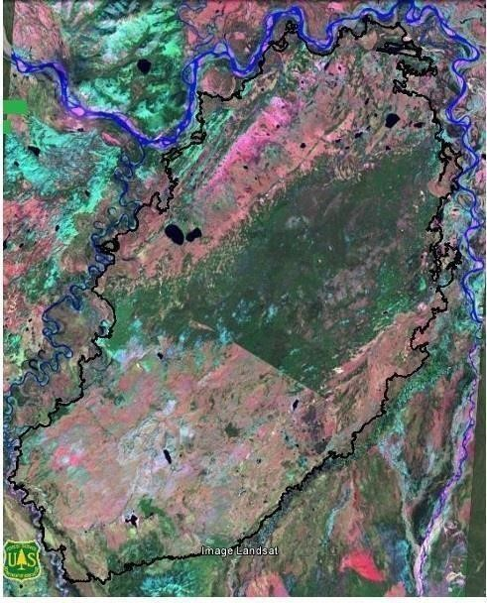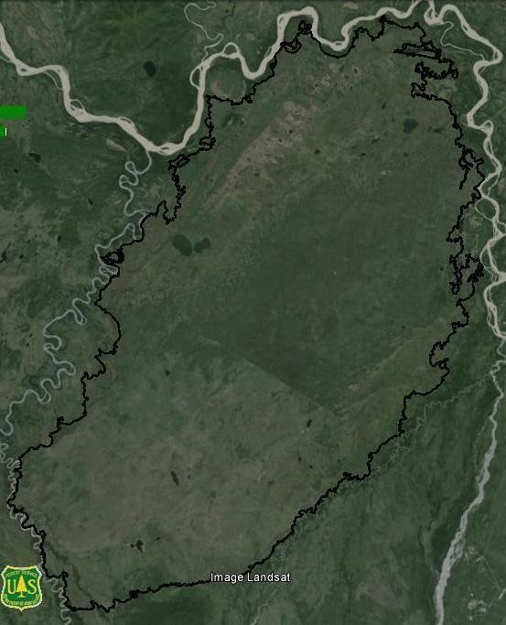

Mapping Burn Severity

Part 1: Create a map of high severity burns of the 2009 Alaska Railbelt Complex Fire.

What you Need:
Alaska Railbelt Complex Fire Burn Severity Image.
Alaska Railbelt Complex Vegetation Map.
Felt-tipped color markers or sharpees (black, red and green). A Pencil.

Mapping Steps:
- Familiarize yourself with the features of the burn severity image:
  - Find an example of each different legend item on your map.

- Identify and mark high severity burn features with a pencil.
  - Examine your map to find all areas where high severity burns occurred. Using a pencil, place a small X in the center of each high severity burn area. Place a small question mark (?) by any places that you are uncertain about.

- Delineate and trace high severity burn area perimeters:
  - Using a colored marker, trace the perimeter of each high severity burn area.
  - Using a different colored marker, delineate and trace the perimeters of islands or pockets of moderate and light burn severity areas and unburned areas that fall within the perimeters of high severity burn areas.

- Finish your map by making a legend with the features that you have mapped.

Part 2: Collecting and Analyzing Map Data

High Severity Burn Vegetation Type, Area, Emissions and Emission Equivalents
 | Predominant  Vegetation Type | Total  Square  Count | Total Acreage | Percent of  Total Burn  Area | CO2 Emissions (Tons) | Equivalent # of Cars on Road/Yr | Equivalent # of  Coal Burning  Power Plants/Yr
High Severity Burn

- Compare your new map with the pre-burn vegetation map. What vegetation type accounts for most of the high-severity burn area?

- Calculate the acreage of high severity burns on your map. Each white square on the burn severity image is approximately 1,000 acres. Round up for squares that contain 50% or more area of high severity burns. The total area within the burn perimeter is 523,000 acres. (For perspective, one acre is about the size of a football field.) Fill in the table above.
- Based upon results from a laboratory study, scientists found that every acre of black spruce feathermoss forest that is subject to high severity burns releases 100 tons of CO2 into the atmosphere. (Note that Black Spruce Feathermoss forest is the predominant forest type in the case study area.) What is the total contribution of CO2 to the atmosphere from this fire?

- The average car in the United States emits 4 tons of carbon dioxide each year. In terms of CO2, how many cars on the road for a year was this fire equivalent to?

- The average coal-fired power plant in the United States emits about 5 million tons of carbon dioxide per year. In terms of CO2, how many coal-fired power plants was this fire equivalent to?

Part 3. Forest Fires, Vegetation Change and the Carbon Cycle

- What is the relationship between degree of burn severity and the amount of carbon dioxide, black carbon aerosols and charcoal produced?
_____________________________________________________________________________
_____________________________________________________________________________

- What is the relationship between vegetation type in the study area (forests and grasslands) and the amount of carbon dioxide, black carbon aerosols and charcoal produced?
_____________________________________________________________________________
_____________________________________________________________________________
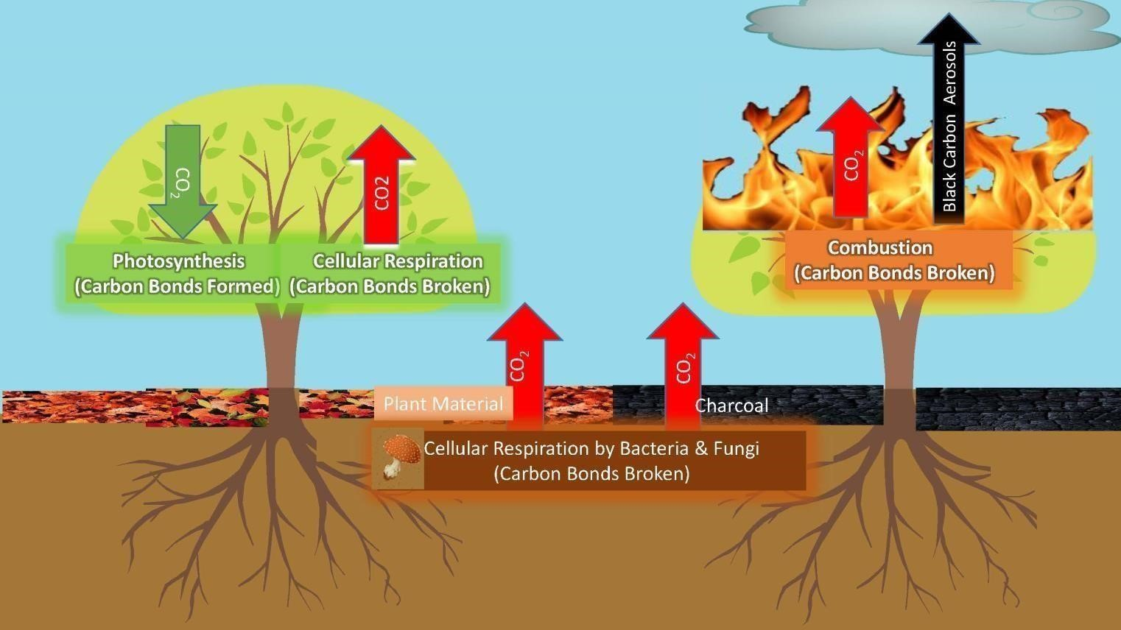

- In a hypothetical scenario, several high severity burns repeated one after another in short succession within the 2009Alaska Railbelt Complex fire burn perimeter. What would you expect to happen to the amount of biomass held in the forest trees and to the rate of cellular respiration in the forest trees and in the forest soil? Explain your reasoning. For each process on the diagram below, place an up or a down arrow to mark whether you expect an increase or a decrease.
_____________________________________________________________________________ _____________________________________________________________________________
_____________________________________________________________________________ _____________________________________________________________________________
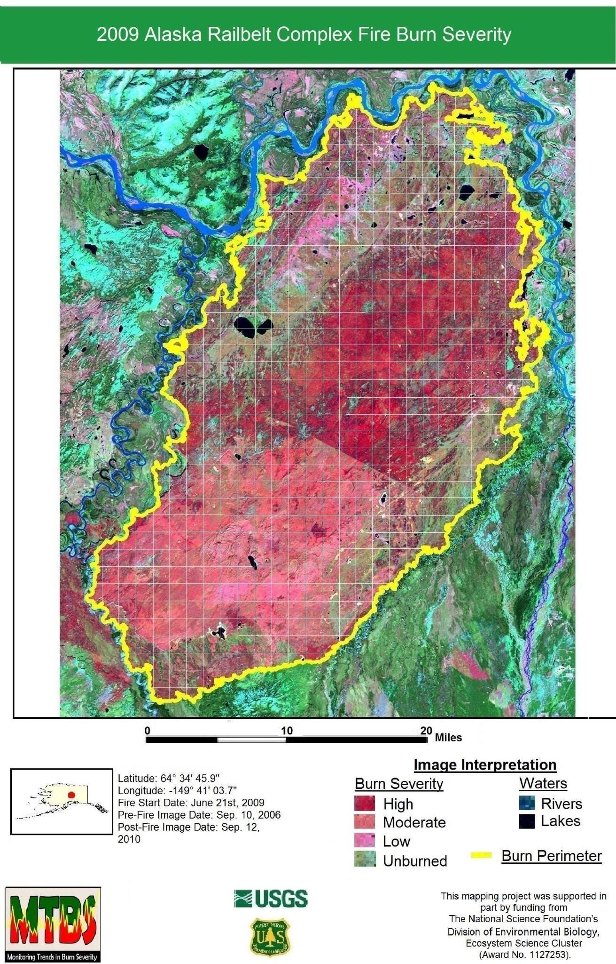

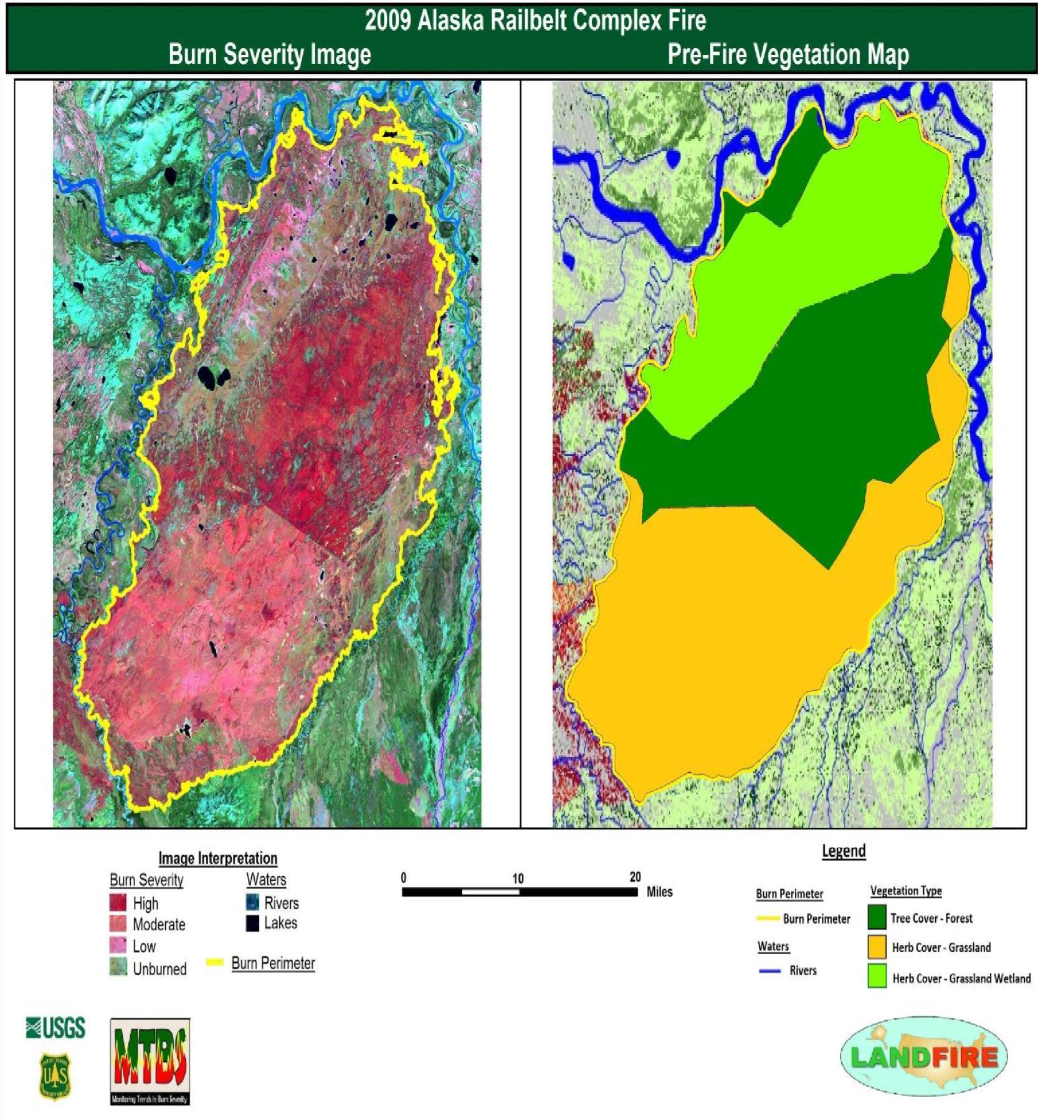

Teacher Support

Part 1: Making a Map
A computer generated map delineating burn severity for the 2009 Alaska Railbelt Complex fire is provided below. Note that the computer generated value for burn severity area is 138,463 acres.

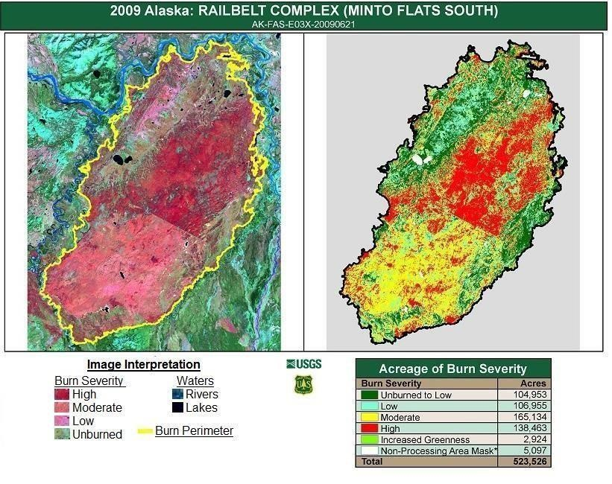
Part 2: Collecting and Analyzing Data

Acceptable Range of Values for Map Measurements And Corresponding Emissions Equilvanets
High Severity Burn Areas | Predominant Vegetation Type | Total  Square  Count | Total Acreage | Percent of Total Burn Area | CO2  Emissions  (Tons) | Equivalent # of Cars on  Road/Yr | Equivalent # of Coal  Burning Power Plants/Yr
Min. Accepted Values | Tree Cover - Forest | 100 | 10  Million | 19% | 10 Million | 2.5  Million | 2
Max Accepted Values | Tree Cover -  Forest | 140 | 14  Million | 27% | 14 Million | 3.5  Million | 3

Useful Links:
GLOBE (Global Learning and Observation to Benefit the Environment): Remote Sensing, Land Cover Mapping and Fire Fuel Ecology Protocol
Earth Observatory: Satellite Image Archive of Fires from Around the World.
LANDFIRE: Maps of fire, vegetation type, fuel types, fire regimes and topography available for all 50 United States.
Monitoring Trends in Burn Severity: Archive of burn severity images searchable by U.S. state, fire name and date.
Burn Area Emergency Response: U.S. Forest Service program that assesses and manages the effects of high severity burns to protect human welfare and the environment.

This lesson plan was made possible by Queens College of The City University of New
York and The National Science Foundation Division of Environmental Biology, Ecosystem
Science Cluster (Award No. 1127253)

For any inquiries, contact:

David Jakim at David.Jakim@gmail.com and Jeffrey Bird at JBird@qc.cuny.edu

