Summary of Research:

Rooftop Turbines in the built environment
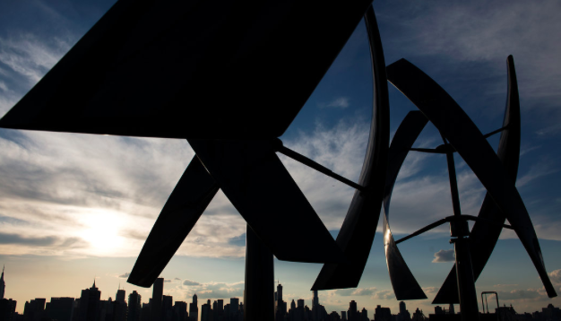
Vertical axis rooftop turbines in Long Island City, NY.

Rooftop turbines (RT) have not taken off in the United States and abroad for several reasons:
- Safety is considered the most critical concern with RTs. Issues arise from ice forming on the blades and fatigue of mechanical parts, including fail-safe mechanisms that prevent the blades from spinning too fast. Instillation of RT will require regular upkeep to ensure public safety.
- Lack of understanding of annual wind averages, turbulence, and extremes. Wind turbulence poses a significant challenge in NYC due to the amount of tall buildings disrupting wind patterns. Building induced turbulence decreases the efficiency of RT, and they produce very little energy.
- The most successful urban wind turbines are on buildings designed to funnel wind to the turbines, such as the Bahrain World Trade Center.
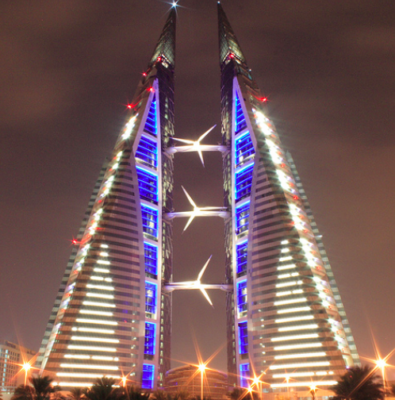
The Bahrain World Trade Center was built to funnel incoming wind to the turbines, reducing turbulence and allowing them to operate more efficiently.

- Many places in the US and abroad do not regulate RT, and there are no international building codes that address RT.

I was unable to access any building codes from other countries. I did find a number of municipalities in the US with laws governing small wind energy systems. Most municipalities have similar codes and regulations for RT. Portland and Philadelphia have the most detailed guidelines.

Portland:
- The “rotor swept area” can be a maximum of 50ft in residential areas, and 150ft in commercial areas.
- Building mounted turbines are subject to minimum building setbacks
- Turbine may be 50% above the base zone height limit or 45ft. above the building whichever is lower.

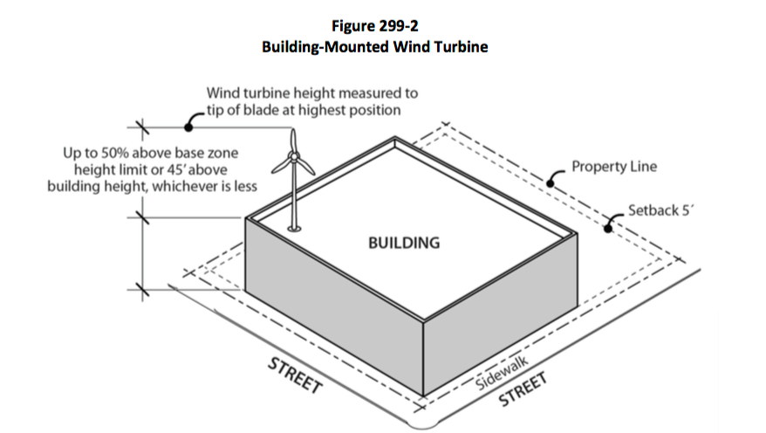

Photo recovered from City of Portland.

Philadelphia:
Roof- and building-mounted small wind energy conversion systems are permitted accessory structures within all zoning districts subject to compliance with the following regulations:

- Turbines must be set back at least 20 ft. from the front building line and, on corner lots, at least 15 ft. from the street side building line.

- Turbines and associated equipment are limited to a height of no more than 15 ft. above the roof or top of the parapet whichever is greater.

- Small wind energy conversion systems must comply with all noise limitations of The Philadelphia Code.

- Small wind energy conversion systems must be safely and securely attached to the rooftop in compliance with the building code.

- When storage batteries are included as part of the wind energy conversion system, they must be placed in a secure container or enclosure meeting the requirements of the building code.

- If a wind energy conversion system ceases to perform its originally intended function for more than 12 consecutive months, the property owner shall remove the system within 90 days after the end of the 12-month period.

Other municipalities have similar rules. The link below is a database of local wind energy ordinances across the United States, most cover RT in varying degrees of specificity.
http://apps2.eere.energy.gov/wind/windexchange/policy/ordinances.asp#links

Low-Head Hydropower in Wastewater Treatment Plants

In general, WWTPs are suitable for hydropower due to mechanically and, biological treated wastewater. In addition, the given discharge is well documented and the technically formed tanks and channels generally allow an implementation. The installation of a hydropower unit within the treatment tanks is rather difficult as the treatment must not be disturbed as well as the outflow has to be guaranteed all the time. Gravity flow is usually used within a WWTP; large heads between the tanks can therefore not be expected. The most likely sight to place a low head hydro generator is the outlet structure. The outlet structure provides enough head to produce a reliable source of energy. Depending on the given structure as well as flow rate and head, turbines, water wheels, Archimedean screws or technologies based on conveyor chains may be applied. If a continuous discharge can be guaranteed they are low in maintenance and contribute constant energy.
Two WWTPs using low-head technology:
1 Deer Island WWTP, Boston, MA
- Once treated wastewater is disinfected, it is discharged into Effluent Channel 1. Flow is then split through two horizontal intake openings at base of Effluent Channel 1 and transmitted through separate rectangular concrete conduits below the disinfection basin to two corresponding hydro turbines. The two intake openings in Effluent Channel 1 are each approximately 20 feet by 18 feet. The intakes decrease to 11 feet by 11 feet at motorized roller intake gates located immediately upstream of the turbines. The average head available is approximately 29 feet. The hydropower facilities include two nominal 1,000 kw Kaplan units, each with flow capacity of approximately 500 cfs (320 mgd). The maximum flow (640 mgd) is approximately equivalent to the maximum flow through secondary treatment at DITP. Turbine runner blades and wicket gates are adjusted to meet changing power demands and changes in flow and head. After the turbines, the turbine effluent conduit joins the outfall chute, which discharges into the outfall shaft, which drops the effluent into the 9.5-mile outfall, tunnel to Massachusetts Bay.
- Since 2002, energy is recovered by the flow of treated wastewater as it drops from the plant into the outfall tunnel shaft through two one-megawatt hydroelectric generators that produce over 6M kWh of electricity, avoiding over $600,000 in electricity costs annually.
- Annual maintenance costs in 2009, 2010, and 2011 were $134,000, $140,000, and $256,000 respectively. The high costs in 2011 were due to unscheduled maintenance costs for the intake gate and shaft seal.
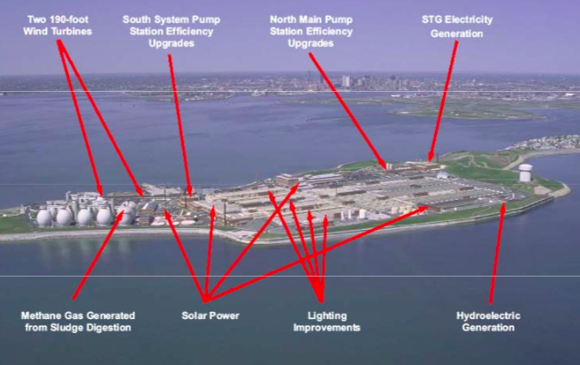Photo recovered from Massachusetts Water Authority.
For more information about this facility contact:
Kristen Patneaude
Program Manager, Energy Management
Massachusetts Water Resource Authority
Kristen.patneaude@mwra.com

2 Point Loma WWTP, San Diego, CA
- The Point Loma Wastewater Treatment Plant is located on a bluff above the Pacific Ocean. Treated wastewater is discharged into the ocean through a 4.5-mile ocean outfall after a 90-foot drop from the plant to the outfall. A 1,350-kilowatt hydroelectric plant captures the energy of the effluent as it flows down the outfall. The power plant, partially funded by a grant from the California Energy Commission, produces up to 1.35 megawatts for sale to the electric grid, enough power to supply energy to 10,000 homes.
- Costs of maintaining the system are approximately $10k/year with a $100k rebuild every 15 years.
- Due to water conservation regulations from the State of California, the plant has had to reduce the run time. The engineering and energy management team at the plant are trying to switch to a smaller system that can run 24 hours a day on the lower volume of water flowing through the outlet.

Photo recovered from San Diego.gov.

For more information about this facility contact:
Richard Snow, P.E, Senior Civil Engineer
Public Utilities Department/ WWTD Engineering
rsnow@sandiego.gov

Large Scale Land Based Wind Turbines

In this section I have compiled a set of important factors to consider when considering laws for land based wind turbines, and included examples of regulatory language in different localities. While researching I could not find any examples of large urban areas comparable to NYC, that developed rules and regulations for large scale wind turbines. The primary reason for the lack of regulation is due to the safety issues associated with large-scale wind energy infrastructure in urban environments, and a lack of public support.

Recommendations for wind turbine regulations:

- Many municipalities utilize Wind Overlay Districts (WOD). A WOD is an area preapproved for wind development, where no wind turbines can legally exist outside of the determined area, and no buildings can reside in the WOD unless by special permit.
- Local regulations tend to defer state and federal authorities for issues such as: Structural safety of the turbine, ensuring the turbine doesn’t interfere with the electromagnetic spectrum, and ensuring storm water runoff complies with regulations.
- Catchall provisions: “Proposed Wind Turbines shall comply with all applicable local, state, and federal requirements including, but not limited to all applicable electrical, construction, noise, safety, environmental and communications requirements.” -Cohasset Zoning Bylaws. Cohasset, MA
- Explicit mentions: “Wetlands: Wind energy conversion facilities shall be located in a manner consistent with all applicable local and state wetlands regulations. Wetland buffer areas may be used for the purposes of providing a clear area.” -Town of Chester Bylaws. Chester, MA
Common issues with Wind Turbines:
- Sound is one of the most controversial issues with wind turbine siting. Most bylaws require developers to check DEP guidance for noise measurement. “The commercial wind energy conversion facility and associated equipment shall conform to Massachusetts noise regulations (310 C.M.R 7.10) and the provisions of the Gloucester Code of Ordinances Chapter 13: Noise. An Analysis, prepared by a qualified acoustical engineer, shall be present to demonstrate compliance with these noise standards and be consistent with the Department of Environmental Protection guidance for noise measurement.” –City of Gloucester Massachusetts Zoning Ordinance. Gloucester, MA
- Shadow Flicker occurs when rotating blades cast a shadow that bothers affected residents. “Shadow/Flicker – Community-Scale Wind Facilities shall be sited in a manner that minimizes shadowing or flicker impacts caused by motion of the rotor blades as they pass in front of the sun. The applicant has the burden of proving that this effect does not have significant cant impact on the neighboring or adjacent uses through either siting or mitigation. It is acknowledged that a degree of shadow/ flicker effect results from any wind turbine, and that the existence of some “shadow flicker” alone shall not be cause for the refusal to permit a Community-Scale Wind Facility.” –Town of Duxbury Community Scale Wind Facilities. Duxbury, MA
- Setbacks are an important regulatory tool that influences visual impact, noise, flicker, and safety. Most bylaws reference the height of the turbine to determine setback. “Community-Scale Wind Facilities and or Monitoring or Meteorological Towers shall be set back a minimum distance equal to 1.1 times the overall height of the Wind Facility from the nearest property line and private or public way and a minimum distance equal to two (2) times the overall height of the Wind Facility from the nearest existing residential or commercial structure not owned by the applicant seeking to permit the Community- Scale Wind Facility and or Wind Monitoring or Meteorological Towers.” –Town of Duxbury Community Scale Wind Facilities. Duxbury, MA
- The Height of turbines in an urban area is quite a challenge, especially for large-scale wind energy systems. Height is also a critical factor for energy production, in both rural and urban areas. “ Wind facilities shall be no higher than 400 feet above the current grade of the land, provided that wind facilities may exceed 400 feet if:
(a) The applicant demonstrates by substantial evidence that such height reflects industry standards for a similarly sited wind facility;
(b) Such excess height is necessary to prevent financial hardship to the applicant, and
(c) The facility satisfies all other criteria for the granting of a site plan approval and a building permit under the provisions of this section.” –Town of Dixmont Wind Energy Facility Ordinances. Dixmont, ME
Lighting is required for airplane safety. Most regulatory language requires turbine developers to comply with FAA regulations. § 5.I “Notwithstanding the requirements of this Section, replacement in kind or modification of a Wind Energy Facility may occur without Town Board approval when there will be [...] (3) no additional lighting or change in facility color; ....”
Within an Application for Special Use for individual WECs, there shall be a:
§ 11.A.8 “Lighting Plan showing any FAA-required lighting and other proposed lighting. The application should include a copy of the determination by the Federal Aviation Administration to establish required markings and/or lights for the structure, but if such determination is not available at the time of the application, no building permit for any lighted facility may be issued until such determination is submitted.”
§ 13.D “Lighting of Tower: No tower shall be lit except to comply with FAA requirements. Minimum security lighting for ground level facilities shall be allowed as approved on the Site plan.”
§ 29.F “Exterior lighting on any structure associated with the system shall not be allowed except that which is specifically required by the Federal Aviation Administration.”
- Scenic impacts Visual Impact: Applications shall include a visual impact study of the proposed WECS as installed, which may include a computerized photographic simulation, demonstrating any visual impacts from strategic vantage points. Color photographs of the proposed Site from at least two locations accurately depicting the existing conditions shall be included. The visual analysis shall also indicate the color treatment of the system’s components and any visual screening incorporated into the project that is intended to lessen the system’s visual prominence.
13.e - All applicants shall use measures to reduce the visual impact of WECSs to the extent possible. All structures in a project shall be finished in a single, non-reflective matte finished color or turbines whose appearance, with respect to one another, is similar within and throughout the Zone, to provide reasonable uniformity in overall size, geometry, and rotational speeds. No lettering, company insignia, advertising, or graphics shall be on any part of the tower, hub, or blades. –Model Wind Energy Facility Local Law for St. Lawrence County Municipalities. St. Lawrence, NY

