The Task: Water Conservation Task 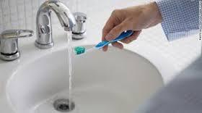

A newspaper says that you can save A LOT of water every year if you turn off the water while brushing your teeth.

How much water can you save in one week if you turn off the water while brushing your teeth?

Questions to think about:
  - What do you know?
  - What do you need to find out?
  - What do you need to assume?

Create a model that shows:
- The amount of water you save each time you brush your teeth if you turn off the water
- The amount water you would save in one week
You can use pictures, numbers and words in your model.

The Task: Water Conservation Task 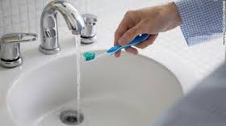

A newspaper says that you can save A LOT of water every year if you turn off the water while brushing your teeth.

How much water can our class save in one day if we all turn off the water while brushing our teeth? How much water can we save in one week?

Questions to think about:
  - What do you know?
  - What do you need to find out?
  - What do you need to assume?

Create a model to support your argument.
You can use pictures, numbers and words in your model.

The Task: Water Conservation Task

A newspaper says that you can save A LOT of water every year if you turn off the water while brushing your teeth.

Your friend claims that in one month his family can fill up 100 buckets with the water they waste while brushing their teeth.
Do you believe him? What could make his claim reasonable?

Create a model to support your argument.

Going further: How could your family test this claim at home?

Questions to think about:
  - What do you know?
  - What do you need to find out?
    - How many people are in your friend’s family?
    - How often do they brush their teeth?
  - What do you need to assume?
    - How much water can a “bucket” hold?
    - How long does the water run while someone brushes his/her teeth?

