Warm Up: Making One Jump Rope

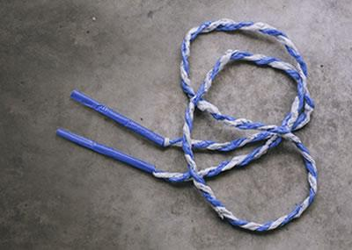

You want to make one jump rope.
How many plastic bags do you need?

What do you know that can help you figure this out?

Draw a model of your jump rope.
Use words, numbers and equations to show:
how many plastic bags you will need to make your rope

Warm Up: Making a Jump Rope with Handles

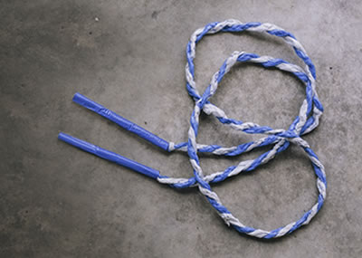

You want to make one jump rope.
How many plastic bags do you need?
How much duct tape do you need?

What do you know that can help you figure this out?

Draw a model of your jump rope.

Use words, numbers and equation to show:

how many plastic bags you will need to make the rope

how much duct tape you will need to make the handles
Version A: Making Jump Ropes for our Class

We want to make a jump rope set for our class.
A set contains jump ropes of different lengths.
How many plastic bags will we need?

What do you know that can help you? | What do you need to find out? | What assumptions do you have to make?

Your plan for making the jump ropes must show:
- How you know that you will have enough jump ropes for your class, without a lot of extra
- How many plastic bags you will need
- How others could use your plan to make jump ropes for students in their school.

Use pictures, numbers and words to show that your plan will work.

Version B: Making Jump Ropes for P.E. (Gym Class)

We want to make a jump rope set to be used in P.E. (Gym Class). A set contains jump ropes of different lengths.

How many plastic bags will we need?

Questions to think about:
  - What do you know that can help you figure this out?
  - What do you need to find out?
  - What assumptions do you have to make?

Your plan for making the jump ropes must show:
- How you know that you will have enough jump ropes for PE class, without a lot of extra
- How many plastic bags you will need
- How others could use your plan to make jump rope sets for PE classes at their school.

Use pictures, numbers and words to show that your plan will work.

Version C: Making Jump Ropes for a Community Center

We want to make a jump rope set for the [insert] community center. A set contains jump ropes of different lengths.

How many plastic bags will we need?

Questions to think about:
  - What do you know that can help you figure this out?
  - What do you need to find out?
  - What assumptions do you have to make?

Your plan for making the jump ropes must show:
- How you know that you will have enough jump ropes for the community center, without a lot of extra
- How many plastic bags you will need
- How others could use your plan to make jump ropes for other community groups or organizations.

Use pictures, numbers and words to show that your plan will work.

Version D: Making Jump Ropes for a School-Wide
Jump Rope Event

We want to make enough jump ropes so that all students at your school can participate in the school-wide jump rope event.
How many plastic bags will we need?

Questions to think about:
  - What do you know that can help you figure this out?
  - What do you need to find out?
  - What assumptions do you have to make?

Your plan for making the jump ropes must show:
- How you know that you will have enough jump ropes for the school-wide jump rope event, without a lot of extra
- How many plastic bags you will need
- How others could use your plan to make jump ropes for students in their school.

Use pictures, numbers and words to show that your plan will work.

Making Jump Rope Handles

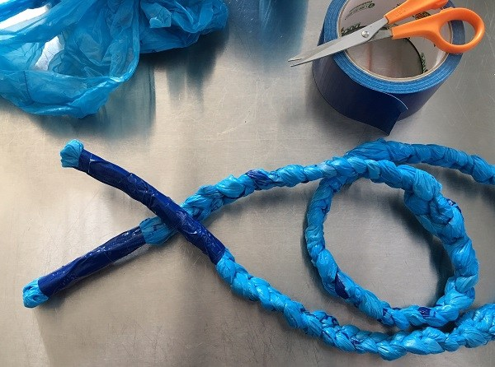

You will use duct tape to make the jump rope handles.
How much duct tape will you need for all the jump ropes included in your plan?

Questions to think about:
  - What do you know that can help you figure this out?
  - What do you need to find out?
  - What assumptions do you have to make?

Your plan for making the jump rope handles must show:
- How much duct tape you will need (i.e., how many inches or feet)
- How you know that you will have enough duct tape, without a lot of extra
- How others could use your plan to make handles for jump ropes

Use pictures, numbers and words to show that your plan will work.

How many jump ropes can we make?

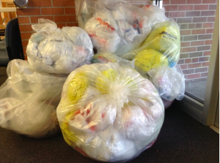

Let’s say we can collect ___________ plastic bags.
Come up with a plan to use these jump ropes to make jump ropes of different lengths for your school. How many jump ropes can we make?

Questions to think about:
  - What do you know that can help you figure this out?
  - What do you need to find out?
  - What assumptions do you have to make?

Your plan for using the plastic bags to make jump ropes must show:
- How many jump ropes (of various lengths) you will make
- How you know that you will have enough plastic bags for those ropes
- An explanation of how many plastic bags will be leftover

Use pictures, numbers and words to show that your plan will work.

Time Needed to Collect the Plastic Bags
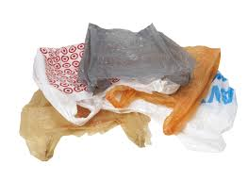

How long will it take us to collect the plastic bags we need?

Questions to think about:
  - What do you know that can help you figure this out?
  - What do you need to find out?
  - What assumptions do you have to make?

Things to consider:
- The average family uses about 15 plastic bags each time they go to the grocery store. How does this compare to your family?
- If you asked everyone in your class to bring in plastic bags that they have at home, how many bags do you think you could collect?
- If you asked all students in the school to bring in plastic bags that they have at home, how many bags do you think you could collect?
- How else might you collect plastic bags?

