Making Picture Frames: 2 DIFFERENT FRAMES

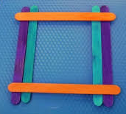 | 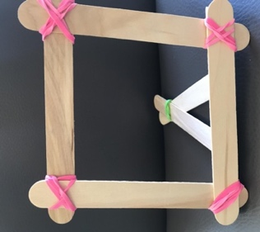 | 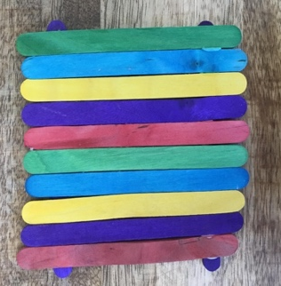
Sketch your Picture Frame Designs:
Frame #1 | Frame #2

1. How many popsicle sticks do you need to make 1 of each frame?
Frame #1 |  | Frame #2
Number of  Jumbo Sticks | Number of  Multi-Color Sticks | Number of  Jumbo Sticks | Number of  Multi-Color Sticks

2. What other materials do you need to make 1 of each frame?

How many magnets? How many rubber bands? How much ribbon?

Frame #1 | Frame #2

Making Picture Frames: A CLASS DISPLAY

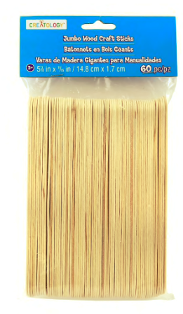  PLAIN JUMBO STICKS  60 PER PACKAGE | 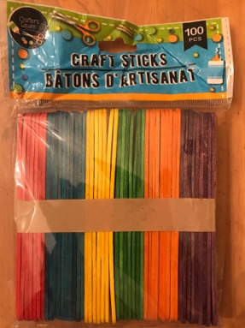  MULTICOLOR STICKS  100 PER PACKAGE

How many packages of popsicle sticks do you need so that every student in your class can make at least one picture frame (using your designs) for the class display?

We want to have enough popsicle sticks, but not many leftovers.

Your plan should explain:
- your assumptions and decisions
- which frames the class should make
- how many of each frame the class should make
- the number of packages of each type of popsicle stick needed for all the frames
- how many popsicle sticks you will have leftover
- how much of other materials needed to make all the frames

Use pictures, numbers, equations and words to show that your plan will work.
FRAME #1: _____________
How many of this frame will you make? __________
 | How many sticks for one frame? | How many sticks for all the frames?
Plain Jumbo Sticks
Multi-Color
Sticks

Other Materials | How much / how many for one frame? | How much / how many for all the frames?

FRAME #2: _____________
How many of this frame will you make? __________
 | How many sticks for one frame? | How many sticks for all the frames?
Plain Jumbo Sticks
Multi-Color
Sticks

Other Materials | How much / how many for one frame? | How much / how many for all the frame?
How many packages of Plain Jumbo Sticks do we need for all the frames in your plan? How many leftover plain jumbo sticks we will have?

How many packages of Multi-Color Sticks do we need for all the frames in your plan? How many leftover multi-color sticks we will have?

How much of OTHER MATERIALS do we need for all the frames in your plan? How much leftover we will have?

