Pricing Guacamole Task
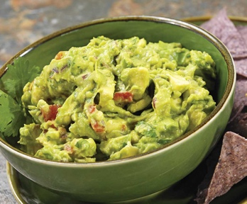

Task A: Pricing Guacamole

Your task is to recommend a menu price for a serving of guacamole.
- Use one of the guacamole recipes and the Task A Guacamole Ingredient Information price list to recommend a price for a guacamole serving for four people and a price for single serving (one person).
- Explain and justify your method for determining a recommended price using words, numbers, pictures and equations. Identify assumptions you made as part of your explanation.
- Explain how the restaurant owner could use your method in the future, or to price other items on the menu.

Pricing Guacamole Task

Task B: Pricing Guacamole

Your task is to recommend a menu price for a serving of guacamole.
- Use one of the guacamole recipes and the Task B: Guacamole Ingredient Information price list to recommend a price for a guacamole serving for four people and a price for single serving (one person).
- Explain and justify your method for determining a recommended price using words, numbers, pictures and equations. Identify assumptions you made as part of your explanation.
- Explain how the restaurant owner could use your method in the future, or to price other items on the menu.

Task C: The Cost of Guacamole in Tucson Restaurants

The table below shows how much Tucson restaurants charge for guacamole. Compare these prices to your recommendation.

Guacamole Prices* at local Tucson Area Restaurants
Restaurant | Price for 3-4 Servings | Price for Individual Serving
Casa Molina | - | $4.75
Michas | $8.50 | $4.25
Guadalajara Grill | $9.95 | -
Reforma | $10.00 | -
El Charo |  | $3.49
Chipotle | - | $2.15
*Prices as of June 8, 2018.

How do you think the restaurants set their prices for guacamole?

Reconsider your recommendation and make changes (if needed).

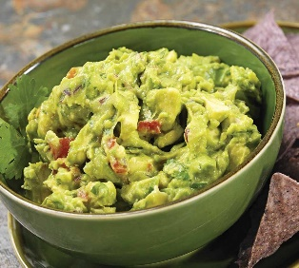

Task D: Pricing Guacamole

Sue Torres, chef and owner of the restaurant Sueños, says that the price of guacamole should be about 4 times the cost of the ingredients.

- How much would Chef Torres charge for a serving of guacamole using your recipe?
- Compare this price to your recommendation. Why do you think they are similar in price or different in price?

Explain and justify your comparison of the recommended prices using words, numbers, pictures and equations.

