Task A: Create a Spinner

Design your own spinner prize wheel using fraction circles.

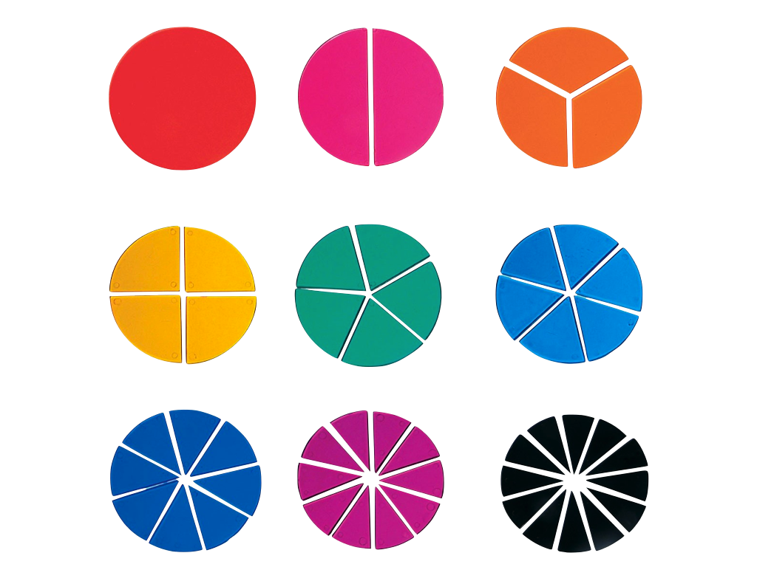

Give examples of spinners that form a whole circle and those that do not.
Develop a method that your class can use to create a spinner with any number of prizes.

Task B: Class/School Reward

Reward systems are a great way to recognize kindness, helpfulness, responsibility and other positive contributions to our school. What would you like to encourage at your school? Design a reward system that uses a spinner to give out prizes for positive contributions to your school.

In your groups:
- Determine what you would like to encourage at the school
- Design a spinner for the rewards (prizes) using fraction circles
- Determine rewards that you would give and what portion/fraction of the spinner you want for each reward
- Write a proposal to your teacher or principal describing how you determined the behaviors, rewards and spinner

Task C: Prize Spinner Wheel Task

Our class gets to design the prize wheel game for the school carnival. Students can buy tickets to spin the wheel and win prizes.

What do you know that can help you with this task?
What do you need to know?
What do you need to assume?
Part 1: Design the Prize Spinner Wheel
- Design a prize spinner wheel for the game
- Determine prizes for the game and decide what fraction of the wheel you want for each prize
- Use fractions to describe your prize spinner, and make sure all the fractional parts add up to 1 whole

Part 2: How Many of Each Prize will you need?
- Consider the number of people that might play the game during the carnival
- Estimate how many of each prize you will need
- You do not want to run out of any of the prizes, but you also do not want to have a lot of leftover prizes
- Use fractions to help you estimate and to explain your reasoning

