TASK: PUNCH PARTY PLANNER – Version A

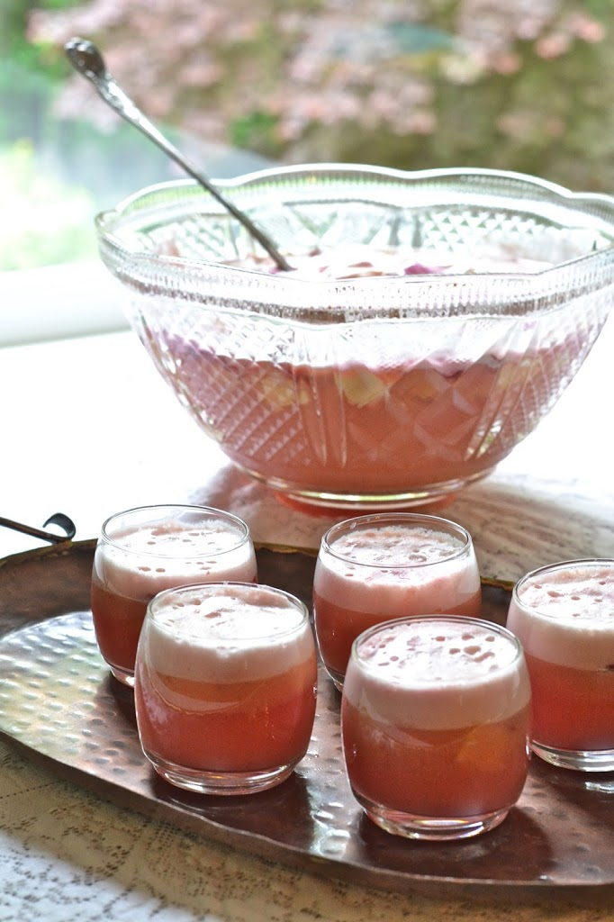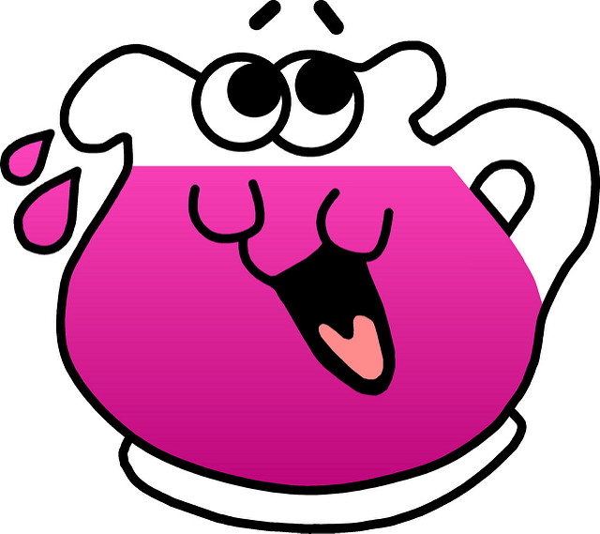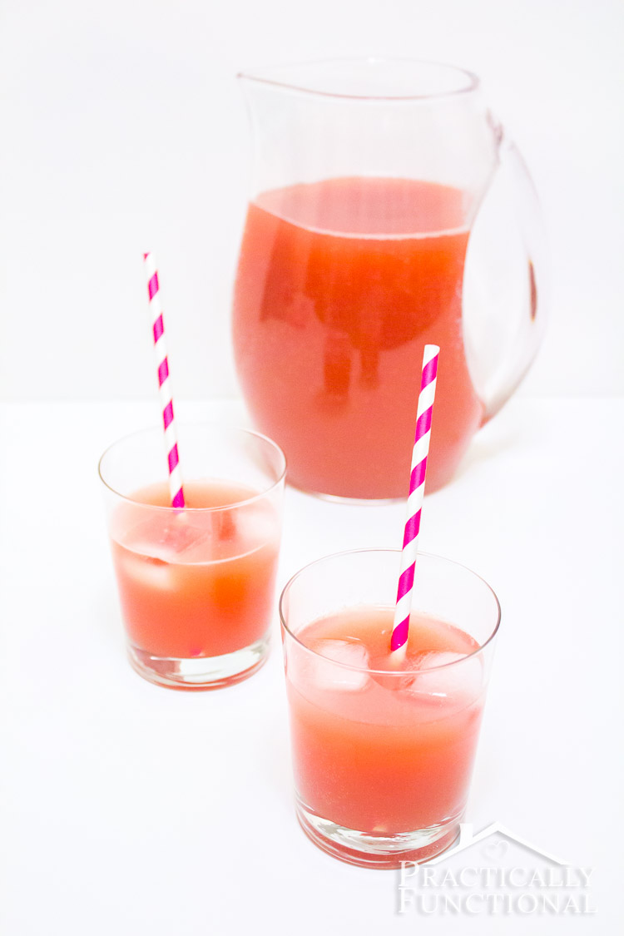

Help me plan a punch party for tomorrow!
Create a recipe that includes 3 juices and a sparkling water. We have the following measuring cups: $1/4 , 1/3, 1/2$and 1 cup.
Recipe rules:
  - Measurements need to be multiples of the measuring cups we have
  - Sparkling water must be more than 1 cup, but less than 2 cups.
  - All juices must be less than one cup.

To help me bring enough ingredients, your plan must show:
- Your assumptions and decisions
- How your recipe follows the punch recipe rules
- How much punch your recipe makes
- How many batches (copies) of your recipe do we need to make so all of us can have a serving of punch?

TASK: PUNCH PARTY PLANNER – Version B

Help me plan a punch party for tomorrow!
Create a recipe that includes 3 juices and a sparkling water. We have the following measuring cups:
$\frac{1}{4}, \frac{1}{3}, \frac{1}{2}, \frac{2}{3}, \frac{3}{4}$ and 1 cup.
Recipe rules:
  - Measurements need to be multiples of the measuring cups we have.
  - Sparkling water must be more than 1 cup, but less than 2 cups.
  - All juices must be less than one cup.

To help me bring enough ingredients, your plan must show:
- Your assumptions and decisions
- How your recipe follows the punch recipe rules
- How much punch your recipe makes
- How many batches (copies) of your recipe do we need to make so all of us can have a serving of punch?

TASK: PUNCH PARTY PLANNER – Version C

Help me plan a punch party for tomorrow!
Create a recipe that includes 3 juices and a sparkling water. We have the

following measuring cups: _____________________________________
Recipe rules:
  - Measurements need to be multiples of the measuring cups we have
  - Sparkling water must be more than 1 cup, but less than 2 cups.
  - All juices must be less than one cup.

To help me bring enough ingredients, your plan must show:
- Your assumptions and decisions
- How your recipe follows the punch recipe rules
- How much punch your recipe makes
- How many batches (copies) of your recipe do we need to make so all of us can have a serving of punch?

