Safe Water for Schools – Version A

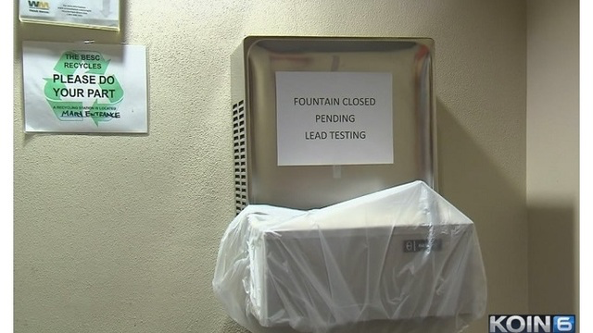

Every year, schools check the drinking water for poisonous chemicals such as lead and copper. In some schools, water fountains are not safe. Signs are posted, “do not use.” If our school water fountains were unsafe, each classroom would use a water dispenser with a large jug of water to make sure everyone has enough water to drink.

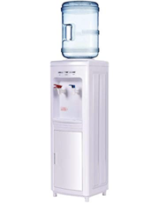

TASK: How many large jugs of water would we need to make sure that everyone in our class has enough drinking water for 1 day?

Questions to consider:
What do you know that could help you to figure this out?
What do you need to find out?
What assumptions do you have to make?

Make a plan for the principal/teacher to make sure everyone in our class has enough drinking water for 1 (day/week/month). The plan must show:
- Assumptions and decisions important to your plan.
- how many large jugs of water are needed
- how you know you will have enough water for everyone in our class
- how others could use your plan help their schools have enough water

Safe Water for Schools – Version B
How long will it last?

Every year, schools check the drinking water for poisonous chemicals such as lead and copper. In some schools, water fountains are covered. Signs are posted, “do not use.” If this happened in our school, each classroom would use a water dispenser with a large jug of water to make sure everyone has enough water to drink.

TASK: Figure out how long 1 large jug of water will last for our class.

Questions to consider:
What do you know that could help you to figure this out?
What do you need to find out?
What assumptions do you have to make?

Make a plan to show how long one jug will last. The plan must show:
- how many days our class will have water
- how you know you will have enough drinking water for everyone
- how others could use your plan help their class have enough water to drink
ADDITIONAL INFORMATION

WATER JUGS
A large jug holds 5 gallons of water.

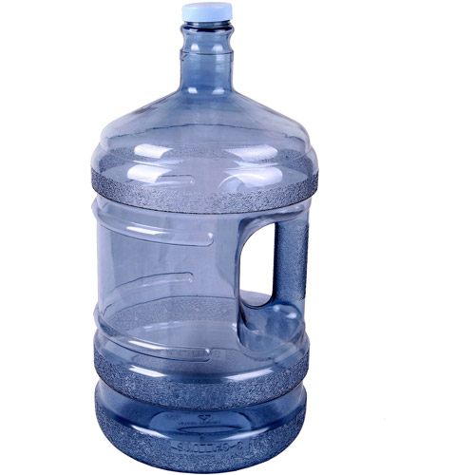

There are 16 cups of water in 1 gallon.

HOW MUCH WATER DO WE NEED TO DRINK EACH DAY?
Here are recommendations for how much water people should drink each day.

Age | How many cups of water per day?
4 to 8 years old | 5 cups
9 to 13 years old | 7-8 cups
14-18 years old, and adults | 8-10 cups

