Safe Water for Schools

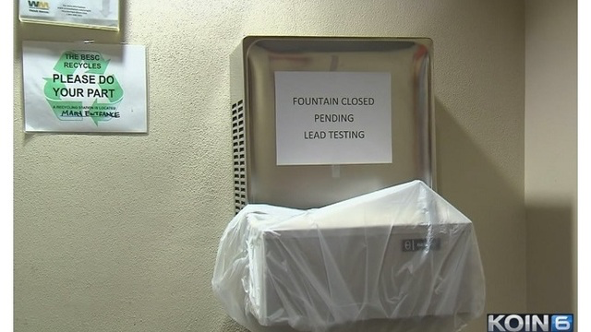

Every year, schools check the drinking water for poisonous chemicals such as lead and copper. In some schools, water fountains are covered. Signs are posted, “do not use.” If this happened in our school, we would use water dispensers with large jugs of water to make sure everyone has enough water to drink. Our portables already have these water dispensers because there are not water fountains.

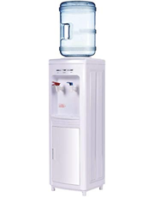

TASK: How many large jugs of water would we need to make sure that everyone in our class (or grade level) has enough drinking water for 1 month?

Questions to consider:
What do you know that could help you to figure this out?
What do you need to find out?
What assumptions do you have to make?

Make a plan for the teacher to make sure everyone class (or grade level) has enough drinking water for 1 month. The plan must show:
- how many large containers/jugs of water are needed
- how you know you will have enough water for everyone in our class (or grade level)
- how others could use your plan help their schools have enough water

ADDITIONAL INFORMATION

WATER JUGS
A large jug holds 5 gallons of water.

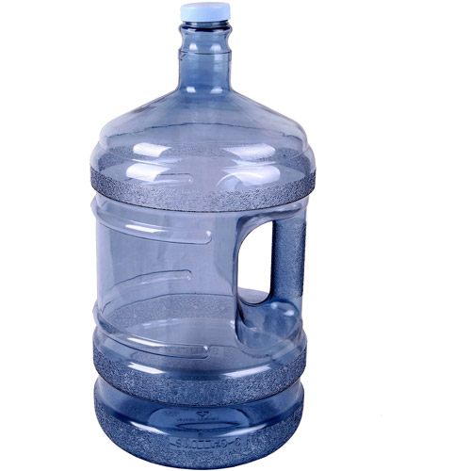

HOW MUCH WATER DO WE NEED TO DRINK EACH DAY?
Here are recommendations for how much water people should drink each day.

Age | How many cups of water per day? | How many ounces of water per day?
4 to 8 years old | 5 cups | 40 ounces
9 to 13 years old | 7-8 cups | 56-64 ounces
14-18 years old, and adults | 8-10 cups | 64-80 ounces

