Warm-Up Task: Shower Versus Bath
Version A

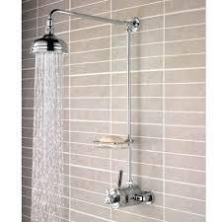
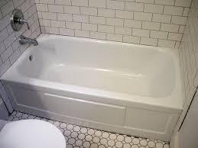

- How much water do you use when you take a bath?

- How much water do you use when you take a shower?

Questions to think about:
  - What do you know?
  - What do you need to find out?
  - What do you need to assume?

The Task: Shower Versus Bath
Version B

Which uses less water, a shower or a bath?

Some people say a shower uses less water.
Other people say a bath uses less water.
Who do you think is right?

Questions to think about:
  - What do you know?
  - What do you need to find out?
  - What do you need to assume?

Compare the two options, and show which uses less water, and how you know.
You can use tables, pictures, numbers and words in your explanation.
Extension Task: Shower Versus Bath
Version C

What if your family only took baths? How much water would you use in a week?
What if your family only took showers? Then how much water would you use in a week?

Which option is better, and why?

Questions to think about:
  - What do you know?
  - What do you need to find out?
  - What do you need to assume?

Compare the two options, and show which uses less water, and how you know.
- You can use tables, pictures, numbers and words in your explanation.

