Warm Up Task: Table Pizza Party

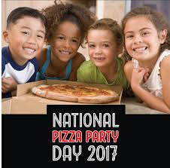
National Pizza Party Day is the Third Friday in May!

If your table has a pizza party, how many pizzas should you order? You want to have enough pizza, but not a lot of extra.

Questions to think about:
  - What do you know?
  - What do you need to find out?
  - What do you need to assume?

Make a plan for how many pizzas to order

You can use pictures, numbers and words to show your plan. Show that you will have enough pizza for everyone at your table, without a lot of extra.

The Task: Class Pizza Party

National Pizza Party Day is the Third Friday in May!

If your class has a pizza party, how many pizzas should you order? You want to have enough pizza, but not a lot of extra.

Questions to think about:
  - What do you know?
  - What do you need to find out?
  - What do you need to assume?

Make a plan for how many pizzas to order
You can use pictures, numbers and words to show your plan. Show that you will have enough pizza for everyone in your class, without a lot of extra.
The Task: Pizza Party with Families

National Pizza Party Day is the Third Friday in May!

Your class is having a pizza party, and families are invited.
How many pizzas should you order? You want to have enough pizza, but not a lot of extra.
Your friend says you need to order 20 pizzas.
Do you agree with your friend? What would make your friend’s statement reasonable or unreasonable?

Questions to think about:
  - What do you know?
  - What do you need to find out?
  - What do you need to assume?
Explain whether you agree or disagree that you need
20 pizzas for the class and family pizza party.
- Use pictures, numbers, and words
- Explain how you know that 20 is a reasonable number of pizzas to order, or how you know that an order of 20 pizzas is not reasonable.

