The Task: Popcorn for Class Movie Night

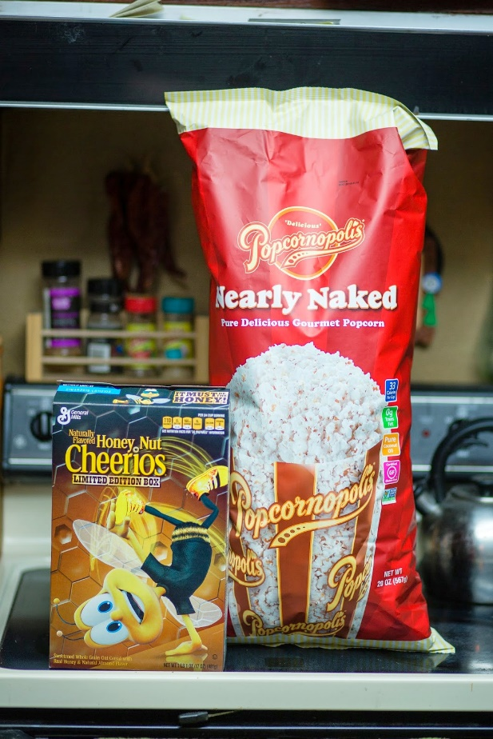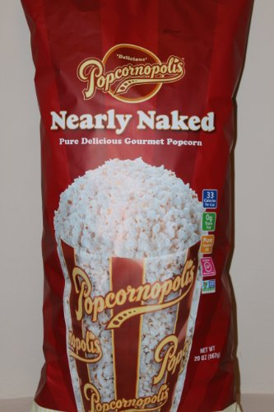

Your class is having a movie night for students and their families. You will serve popcorn as a snack. You will get giant bags of popcorn to share and scoop out servings for each person.

How many giant bags of popcorn does your class need for the movie night?
You need to make sure there is enough popcorn, but not a lot of leftover popcorn.

Make a plan for how to share the popcorn.
Your plan to must show how:
- everyone gets enough popcorn
- it is a fair plan
- you can use the plan in other sharing situations
You can use pictures, numbers and words in your plan.

The Task: Popcorn for School Movie Night

Your school is having a movie night for students and their families. They will serve popcorn as a snack. They will get giant bags of popcorn to share and scoop out servings for each person.

How many giant bags of popcorn does the school need for the family movie night?
You need to make sure there is enough popcorn, but not a lot of leftover popcorn.

Make a plan for how to share the popcorn.
Your plan to must show how:
- everyone gets enough popcorn
- it is a fair plan
- you can use the plan in other sharing situations
You can use pictures, numbers and words in your plan.
Optional Information

This is the nutrition label from a giant bag of popcorn.
What does this tell you about the bag of popcorn?
How can you use this information to help you share the bag of popcorn?

