The Task: Pretzels for Snack

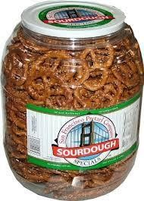

On Monday, your class gets a giant container of pretzels to share for snack time. You have snack every day, and you want the pretzels to last the whole week.

What can you do to make sure the pretzels last all week? How can you figure out how many pretzels to give to each student? Make a plan to share the pretzels in a fair way over the week.

Your plan to share the pretzels must show how:
- the pretzels last for a week
- it is a fair plan
- you can use the plan in other sharing situations

M2C3 Project (2018)

You can use pictures, numbers and words to communicate your plan.

M2C3 Project (2018)

