The Center for Excellence in Teaching, Learning & Leadership 
Queens College, City University of New York

Brightspace Quizzes

Brightspace Guides Collection

## Set up a Quiz

1. In your Brightspace course, go to a content module and click on Upload/Create.  
   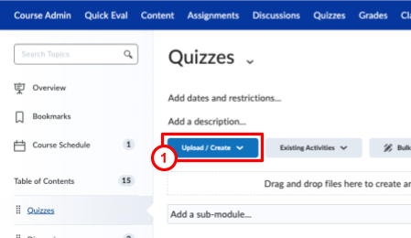
2. Click on New Quiz.  
   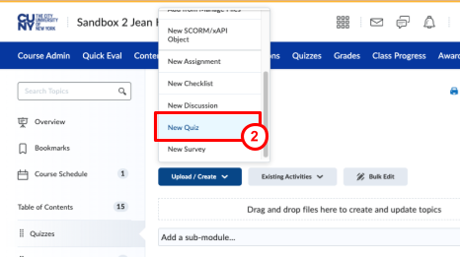
3. Enter a Quiz Title.
4. Enter a due date.  
   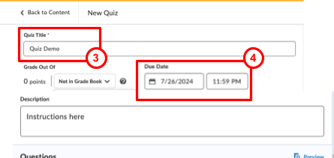
5. To enter Grade Points, you must first add the quiz to the Grade Book. Click on the Not in Grade Book drop-down menu and select Add to Grade Book.
6. Then enter Points under Grade Out Of.  
   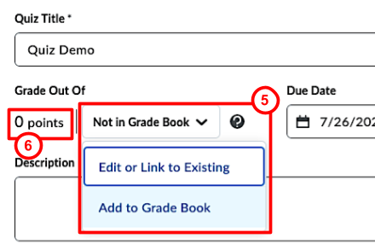
7. Under Availability, enter start date and end dates.  
   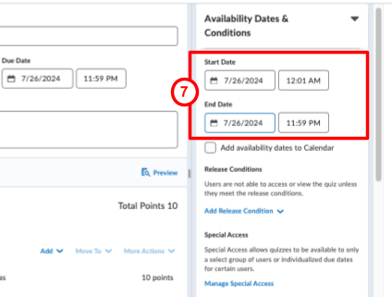
8. Click on the Hidden/Visible toggle button to make the quiz visible. You *must* make it visible regardless of the Availability Settings. This will *not* override the Availability Settings.  
   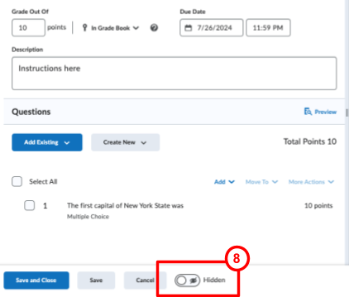
9. Under Timing & Display, take a look at the options such as the **Paging drop-down menu**; **Prevent going back to previous pages**; **Shuffle questions**, etc. and select whatever is appropriate for your quiz.  
   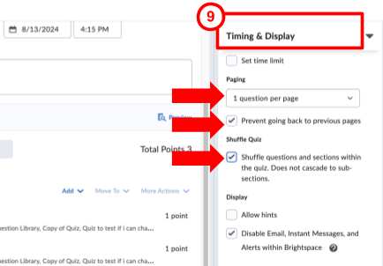
10. Under Attempts & Completion, select desired options.  
    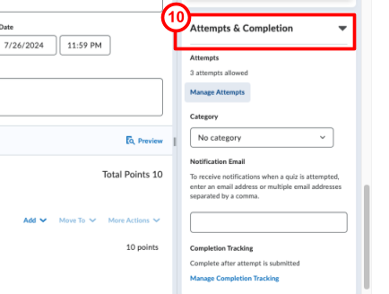
11. Under Evaluation & Feedback, select desired options  
    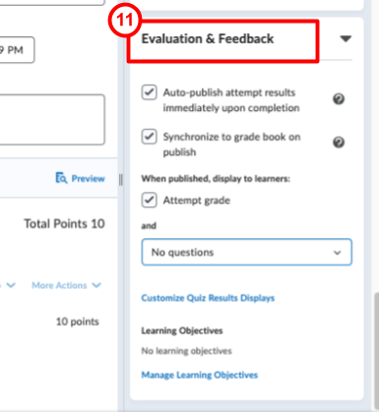
12. To add questions, click on Create New.
13. Select a question type. In this example, we are creating a Multiple Choice question.   
    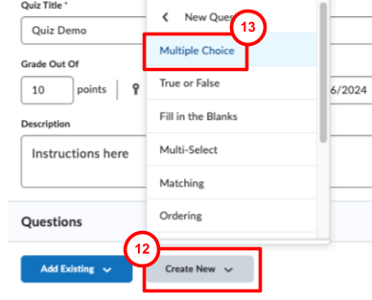
14. Add answers. The default setting is four answers but you can add more, or delete one if you want only three answers.
15. To identify the correct answer, click on the circle to the left of it.
16. Enter points for each question  
    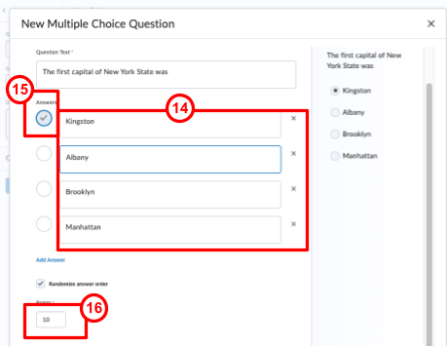
17. Click on Options to add feedback for each answer; add a hint; a short description; custom weights; and enumeration.  
    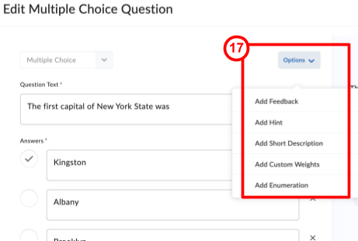
18. Click Save and Close or Save to add a new question.  
    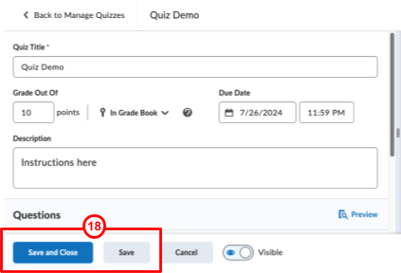
19. To edit a Quiz, click on Quizzes in the Navigation Bar.  
    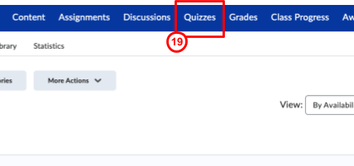
20. Click on the chevron (downward arrow) next to the quiz you want to edit. This will take you to the setup page, where you can edit questions, the due date, grade points, etc.  
    