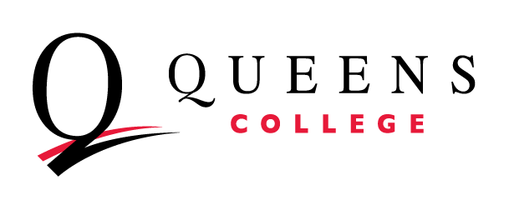
Annual Assessment Report Template
For Administrative and Educational Support (AES) Departments

Department: Academic Year:

Every department at Queens College makes a unique contribution to the College. The purpose of assessment is to showcase that work, and help you make progress toward your goals. Assessment can help you identify challenges, address concerns, and be more deliberate about solutions.

This template provides a place to document the progress made towards achieving the objectives specified in your Annual Assessment Plan with an eye towards how you will assess other goals in the future. Keep in mind that the aim of assessment is improvement over time. Assessment should be useful, actionable, manageable, and sustainable.

Annual Assessment Report: First, copy over the content in the identical grid from the Annual Assessment Plan you completed earlier in the year. Then, add in your assessment findings/results in the 4th column. Lastly, identify what actions you will take based on these findings. This will be the connection between this year’s assessment activities and next years’ assessment activities.

First Goal assessed this year:
How does this goal support or connect to the QC Mission or the QC Strategic Plan?
(1) Objectives Assessed | (2) Assessment Methods, Tools, or Measures | (3) Expected Results or Benchmarks | (4) Findings | (5) Use of Findings

Second Goal assessed this year:
How does this goal support or connect to the QC Mission or the QC Strategic Plan?
(1) Objectives Assessed | (2) Assessment Methods, Tools, or Measures | (3) Expected Results or Benchmarks | (4) Findings | (5) Use of Findings

Additional Comments:

