COACHE Survey Key Takeaways:
When given a list of aspects that they value about working at Queens College, which ones do faculty select as a BEST aspect of working at Queens College?

- Quality of colleagues
- Geographic Location
- Quality of undergraduate students
- Academic Freedom
- Diversity
- Support of colleagues

When given a list of aspects that they value about working at Queens College, which ones do faculty select as a WORST aspect of working at Queens College?

- Teaching Load
- Quality of Facilities
- Compensation
- Lack of Support for Research/Creative Work
- Too much Service
- Cost of Living

Faculty were asked about different aspects of working at Queens College. Here is a comparison of the survey responses across benchmarks. A higher score corresponds to greater satisfaction.

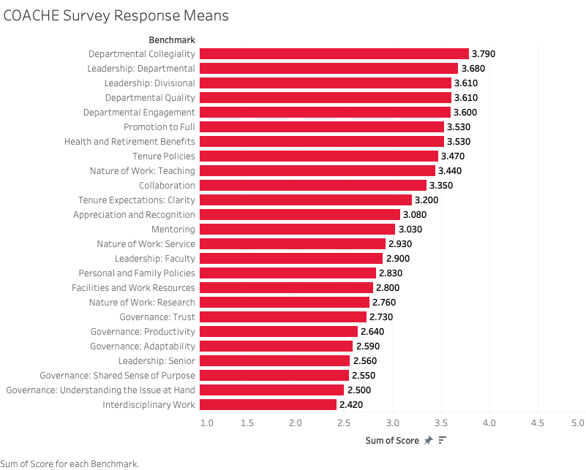

Likert Scales for questions within Benchmarks:
1=Never; 2=Seldom; 3=Occasionally; 4=Regularly; 5=Frequently
1=Strongly disagree; 2=Somewhat disagree; 3=Neither agree nor disagree; 4=Somewhat agree; 5=Strongly agree
1=Very ineffective; 2=Somewhat ineffective; 3=Neither effective nor ineffective; 4=Somewhat effective; 5=Very effective
1=Very dissatisfied; 2=Dissatisfied; 3=Neither satisfied nor dissatisfied; 4=Satisfied; 5=Very satisfied
1=Very unclear; 2=Somewhat unclear; 3=Neither clear nor unclear; 4=Somewhat clear; 5=Very clear
Additional answers can include: I don’t know, Not applicable, Decline to answer
Here is another way to visualize the same information. We see the distribution of the scores (1 through 5) for each of the benchmarks.
As a reminder, a higher score corresponds to greater satisfaction.

