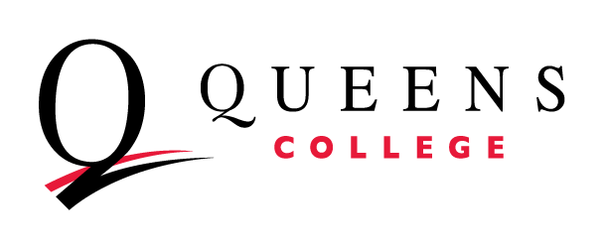
Annual Report for Academic Departments and Programs
Department: Academic Year:

The purpose of this Annual Report for Academic Departments and Programs is to:
- provide a forum for each department and program to reflect on its current state, share its progress in key areas, and request support.
- serve as an engine for curricular review, assessment of learning, and improvement of department effectiveness, incorporating a DEI perspective. (Strategic Plan Goal 1c)
- help departments and programs align their activities with their mission and goals and the College’s Strategic Plan, provide an assessment of achievement toward the Strategic Plan, and inform adjustments to these as needed.
- scaffold the periodic Academic Program Review Self-Study and foster a departmental culture of planning, assessment, and continuous improvement.

The report is divided into five sections: Faculty Update, Student Update, Initiatives, Requests, and Comments. Expand the boxes as necessary to fully answer the prompts.

Section 1: Faculty Update
Strategic Plan Goals:
3a. Foster the conditions that allow faculty scholarship, creativity, and research to thrive and have an impact on teaching excellence, student learning, and student success, as well as diversity, equity, and inclusion.

- Please comment on your current faculty demographics, recent hires and attrition, and recruitment and retention initiatives for diversification.
- Please list significant awards, grants, and fellowships.
- Please discuss the distribution of administrative reassigned time and its outcomes.

Section 2: Student Update
Strategic Plan Goals:
1a. Across disciplines, offer a distinctive, coherent QC learning experience that is aligned with QC’s mission and values.
1b. Offer a consistent General Education program to students.
2d. Close the retention and achievement gap for BIPOC students, students with disabilities, and economically disadvantaged undergraduate and graduate students.
3b. Systematize the integration of scholarship, creativity, and research into curricular and pedagogical practice.
3c. Engage undergraduate and graduate students in scholarship, creativity, and research.

- Please complete and attach your Assessment Progress Report.
- Please comment on student enrollment, retention, graduation, time to degree, and DEI initiatives. Consult the Tableau Dashboard for accurate data. Address both undergraduate and graduate students where appropriate.

Section 3: Initiatives
Strategic Plan Goals:
1d. Develop systems, structures, and policies that facilitate change management and fundamentally improve curriculum, teaching, and interdisciplinary collaboration.
2a. Build DEI into our campus-wide policies, processes, and interactions.
2e. Strengthen recruitment, retention, and support of BIPOC faculty, staff, and administrators, as well as faculty, staff, and administrators with disabilities.
5a. Woo BIPOC students by increasing their sense of belonging from our first interactions with them, identifying and removing barriers to their recruitment, retention, and graduation.
5b. Develop and innovate cohort-based or cohort-like experiences to serve all students.
5c. Build our whole community membership—as advisors, mentors, coaches, navigators—in support of student success, using many tools, including technology, to facilitate connections.

- Please briefly describe any faculty, student, pedagogical or curricular initiatives that are currently underway to enhance your department or program.
- State two to five objectives for the next Academic Year and identify their linkage to department goals and outcomes or to the Queens College Strategic Plan.

Section 4: Requests
- Please attach your most recent Budget Request Template.
- Please add any additional requests you feel are necessary to support your department or program.

Section 5: Comments
- Please use this space to share anything else about your department or program that you would like to tell us.
Do you have any additional accomplishments, concerns, or needs that you would like to share?

