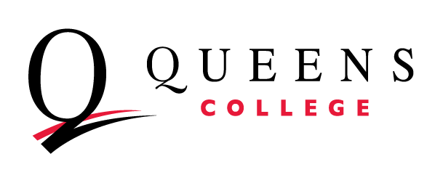
2026 Assessment Overview Survey

Department / Program: (Insert Department / Program Name here)

The 2026 Assessment Overview Survey has four parts: Departmental Policies, General Education Assessment, the Self-Assessment Rubric, and Professional Development Requests. This is a collaboration between the Academic Assessment Council and the General Education Council.

Departmental Policies:
- How does your department/program ensure consistency of learning objectives and educational quality across different sections of the same course?

- Please verify that your department/program has submitted your General Education Plan to the General Education Council.
(If not, see here for the guidance, develop it, and send it to the General Education Council--emails below. Here is an example General Education Plan.)

General Education Program Assessment:
- In your General Education Plan, you describe how you ensure the General Education (Pathways) Learning Objectives are in the syllabus of every Pathways class section. (This is across ALL Pathways Designations.)
  - In Spring 2026, how many Pathways sections did your department/program run?

  - What percentage of the syllabi in your Pathways sections had the General Education Learning Outcomes?

  - What roadblocks, if any, did you encounter when collecting this information?

- The General Education Council is in the process of assessing Flexible Core Pathways Courses and their instructors should have received a survey from qc.oie@qc.cuny.edu. Please follow up with the instructors who are teaching these courses to ensure they submit their survey responses by March 31. If your instructors have any issues with or questions about the survey, please contact either Yan.Sun@qc.cuny.edu or Christine.Ramadhin@qc.cuny.edu.

Self-Assessment Rubric:
We are collecting updates on your department’s progress towards a strong foundation for sustainable assessment practice. Mark one category per row about the current state of assessment practice in your department.

Capacity Criteria | Developed | Emerging | Needs Work
Course Learning Objectives in place | □ All courses offered by the department include course learning objectives that are student-centered, observable, and aligned with assignments. | □ All courses offered by the department include course learning objectives, but not all are student-centered, observable, and aligned with assignments. | □ Not all departmental courses have student learning objectives.
Program Learning Objectives in place | □ Each departmental program has program learning objectives that are student-centered, observable, and aligned with courses. | □ Each program has learning objectives, but not all are student-centered, observable, and aligned with courses. | □ Not all departmental programs have overall learning outcomes.
Curriculum Map in place | □ The department clearly aligns curricular offerings to program-specific learning objectives. | □ The department ties curricular offerings to levels of learning, but not yet to program-specific learning objectives. | □ The department does not yet explicitly tie curricular offerings to program learning objectives.
Assessment Methods in place | □ The department has developed assessment methods that effectively convey information about how well students are meeting learning outcomes, about program support for students and DEI, and alumni outcomes. | □ The department has developed program assessment methods, but they do not yet follow best practices. | □ The department has not yet developed methods to assess student learning or support.

Professional Development Requests:
Can we support your progress from Needs Work to Emerging or from Emerging to Developed? What topics would you like to see covered in an in-person workshop or supported through online videos by the Office of Institutional Effectiveness and the Academic Assessment Council?

- Developing Program Learning Objectives
- Developing Course Learning Objectives
- Developing assignments that can assess Course Learning Objectives
- Determining whether Learning Objectives are student-centered and observable
- Aligning Course Learning Objectives with Program Learning Objectives
- Developing a curriculum map
- Developing a plan to assess Program Learning Objectives
- Developing a plan to assess Course Learning Objectives
- Developing assessment plans around learning outcomes by demographics, alumni outcomes, student support.
- Information about how to use QC and CUNY Tableau data
- Other:

